SUPERIOR COURT OF WASHINGTON FOR KING COUNTY

STATE OF WASHINGTON,  Plaintiff,  vs.  D’ANDRE L. GLASPY,  Defendant. |  | )  )  )  )  )  )  )  )  )  )  )  ) | No. 17-1-07644-5 KNT  DEFENDANT’S TRIAL MEMORANDUM AND MOTIONS IN LIMINE

COMES NOW, D’Andre L. Glaspy, the Defendant by and through counsel, Anna Samuel and Michael Schueler, King County Department of Public Defense - Associated Counsel for the Accused Division, and presents the following trial memorandum and motions in limine.
“With all things being equal, the simplest explanation tends to be the right one.”
- William of Ockham, 1287-1347,
“When you have eliminated all which is impossible, then whatever remains, however improbable, must be the truth.”
- Sir. Arthur Conan Doyle, 1859-1930

The simplest explanation for the untimely death of M.Z.H.-A. is that he died of heart stoppage caused from infection. This infection led to a hypoxia, or oxygen deprivation, which caused him to faint and his heart to stop. This late-stage infection also caused a clotting disorder called Disseminated Intervascular Coagulation (DIC) to occur. DIC occurs with frequency in late-stage infection and mimics bruises on the body. As a result of this, Mr. Glaspy, who stands 6’5” tall and weighed at least 410 pounds, conducted CPR on M.Z.H.-A., and, under improper instruction from the 911 operator, caused M.Z.H.-A.’s ventricle to rupture, as well as caused associated internal injuries to M.Z.H.-A. DIC caused small blood clots to move across M.Z.H.A.’s body leaving petechial hemorrhaging and purpura which caused the responding police officers, medics, and medical examiner to initially believe M.Z.H.-A. had widespread bruising likely attributable to abuse. Because of this rush to judgment, they failed to follow the protocol for investigating sudden unexpected pediatric deaths. In turn, their failure to investigate this case properly has resulted in Mr. Glaspy’s false accusation of murder. They speculate that Mr. Glaspy struck M.Z.H.-A. (or kicked, him, squeezed him, slammed him – it depends on who you ask and when) with such force that it ruptured M.Z.H.-A.’s left ventricle and caused associated internal injuries as well as causing hundreds of discrete small bruises under his skin with barely any corresponding external injuries. Despite no medical evidence or literature suggesting this to be possible, the State posits that M.Z.H.-A. survived for a number of hours after his left ventricle was ruptured – an injury that would be immediately lethal without immediate medical intervention.
When properly evaluated by medical experts who were more rigorous in their investigation, the medical cause of M.Z.H.-A.’s tragic death became clear. Histologic examination of a variety of tissue samples shows a widespread infection including thickening of the alveolar walls in M.Z.H.-A.’s lungs that would have interfered with oxygen absorption by his blood. The microscopic slides also showed what was going on inside M.Z.H.-A.’s body and corresponded with many of the symptoms of illness his mother noted in the days before his death. This infection likely caused hypoxia and the performance of catastrophically bad CPR caused M.Z.H.-A.’s heart to rupture, which would have been fatal. When the impossible scenario presented by the State is eliminated, the confluence of infection and DIC with catastrophically misdirected CPR, fully and most simply explains the injuries and cause of death of M.Z.H.-A.
Mr. Glaspy has no criminal history and stands accused of Murder in the Second Degree as a result of the tragic death of M.Z.H.-A., a two-and-a-half-year-old child he raised and loved as his own son. The State has amended the information to add two aggravating factors: that M.Z.H.-A. was particularly vulnerable, and that Mr. Glaspy abused his position of trust. RCW 9.94A. 535 (3)(b),(n). These aggravators expose Mr. Glaspy to a sentencing range of up to life in prison. He has been in custody for nearly five years while his defense team has worked to unwind a false, flawed, and factually incorrect accusation. The State’s investigation showcased rushes to judgment on the part of law enforcement and the King County Medical Examiner’s Office (KCMEO), lapses in following protocol and procedure by KCMEO, and entrenchment by the State’s medical doctors who have latched on to a novel theory of abuse such that this case is the first of its kind in history. What the State and their medical team ignore is the obvious signs of medical illness that M.Z.H-.A. suffered pending his tragic death. They ignore the inescapable fact that Mr. Glaspy, weighing 410 pounds, was told to “push as hard as you can” when giving CPR to a collapsed M.Z.H.-A., who weighed only 36 pounds. And they ignore the simple truth that the injuries found within M.H.Z.-A. on autopsy were immediately lethal and explained more thoroughly by improperly instructed CPR by a giant of a man on a small toddler than by a savage beating that occurred in the span of 30 minutes when no one in the apartment complex saw or heard anything. Their claim ignores there are no injuries to the outer body that would correspond with abusive, intentionally inflicted trauma. Tellingly, nothing in the residence makes it appear that a violent assault occurred there. M.Z.H.-A. died due to an infection causing a cardiac arrest. It is tragic. It is uncommon. But it happens. The marks all over his body are best described by disseminated intravascular coagulation (DIC) – a rare disorder causing clotting throughout the body that appear as petechia or small bruises. But these rare disorders do occur, especially with infection.
The State’s theory rests on this being the first time in recorded history where someone abused a child such that their heart burst, and yet they lived for an hour or more. We know from medical literature that the State’s theory is impossible. The defense theory, while rare and thus improbable, is all that is left. It describes in the simplest terms and with few assumptions exactly what led to M.Z.H.A’s tragic death.
The tragedy of Mr. Glaspy losing his beloved son has been confounded by the tragedy of 5 years of incarceration as he has fought to unwind a tightly wound web of inaccurate medicine, law enforcement who rushed to a conclusion based on the fact that Mr. Glaspy was the last person alive with M.Z.H.-A., and the cutting of corners that masked to the medical team what actually happened here. The further tragedy here would be to let this young innocent man spend the rest of his life in prison for a crime he did not commit.
- TIME ESTIMATE

This trial, including pretrial matters and jury selection, will last approximately 3 months.

- DEFENSE WITNESSES

- Expert Witnesses
  - Dr. Carl Wigren – forensic pathologist.
    - Dr. Wigren is the defense counterpart to the State’s pathologist, Dr. Nicole Yarid.
    - Dr. Wigren will testify about the autopsy findings, the alleged injuries to M.Z.H.-A., and will opine that there was no abuse here, that M.Z.H.-A. suffered from a metabolic bone disorder as evidence by microscopic review of slides of bone; that there were signs of infection throughout the body.
    - He will opine that M.Z.H.-A. suffered from a viral pneumonia which caused hypoxia and death.
    - He will testify that as the body begins to die from hypoxia and lack of oxygen, people will become more tired, lethargic, slow, eat less, and generally seem ill.
    - Specifically, he will opine that M.Z.H.-A.’s heart ruptured, the kidneys had no pathologic diagnosis, there was hemorrhage to the liver, and the lung has severe signs of infection. He will testify that other organs also had signs of trauma. He will further disagree with many of the findings of Dr. Nicole Yarid, specifically that any of the injuries showed signs of healing. His opinion is that M.Z.H.-A. died of an infection and that the injuries seen throughout the body, because they lack healing, are more likely to have been caused by the vigorous CPR that Mr. Glaspy performed. That CPR, he and others will opine, was catastrophically poorly directed by 911 to Mr. Glaspy causing severe damage to M.Z.H.-A. given their size discrepancies.
    - He will also discuss DIC and its role in this case.
    - Dr. Wigren will also testify about ethical concerns around an article published by the State’s witnesses surrounding suspicion of M.Z.H.-A.’s death.
    - Finally, Dr. Wigren will testify about the independent testing and research he performed on this case.
  - Dr. Jeffrey Kahn – Chief of Pediatric Infectious Disease at University of Texas Southwest Medical, one of the largest children’s hospital in the United States.
    - Dr. Kahn, in his role working with living children, is frequently tasked with helping identify infectious disease and viruses. He also has experience with children suffering from injuries that may be related to child abuse or masking as child abuse.
    - He is the only expert on infectious disease and viral infection in this case – the State does not have an expert in this realm.
    - He will explain how virus can quickly spread to multiple organs in a child and can rapidly lead to death. He will further correlate the symptoms described by Ms. Ausler and Ms. Schultz as afflicting M.Z.H.-A. in the days leading to his death as the telltale signs of infection spreading and growing more dire.
    - He will explain how one of the classic features of a life-threatening viral infection is a condition known as disseminated intravascular coagulation, known as DIC. In this condition, the normal coagulation processes are disrupted. Blood clots are extensively formed in the body’s blood vessels and bleeding often occurs specifically from the rectum.
    - He will testify that based on his training and experiences, the findings through M.Z.H.-A.’s body are much better described by viral infection and disseminated intervascular coagulation and are not consistent with his observations on child abuse cases. While rare, he will opine that M.Z.H.-A.’s presentation is more consistent with someone expiring from virus, rather than abuse.
  - Dr. Julie Mack – Professor of Radiology at Penn State University. Dr. Mack is heavily involved in review of radiological findings in both living and deceased patients.
    - Dr. Mack, given her concerns about the evidence the state claims shows that M.Z.H.-A. was abused to death, has agreed to participate and testify in this case pro bono.
    - Dr. Mack will opine that some of the alleged fractures are not likely fractures given a variety of radiological findings. She will opine that on imaging there is no subdural hemorrhage, similar to the radiologist from Seattle Children’s Hospital.
      - This finding of Dr. Yarid, that there was a subdural hemorrhage, is further contested by Dr. Wigren, whereas Dr. Yarid claims there is a subdural hemorrhage. This is important because it relates to alleged injuries to the brain and skull that did not happen.
      - There are no external injuries on the scalp nor any fractures or contusions on the skull. Dr. Yarid did not examine the external scalp for any evidence of inflicted injuries.
    - She will also opine that many of the fractures are older, healing ones, and not from the day of M.Z.H.-A.’s death.
    - She will also opine that there are other explanations for a dural clot other than trauma, including infection. These clots, caused by infection, can lead to a person collapsing without heartbeat – identical to what Mr. Glaspy states happened to M.Z.H.-A.
      - This is critically important as it aligns perfectly with the histological findings of Dr. Auer and Dr. Wigren that M.Z.H.-A. had a severe infection that caused his death.
  - Dr. Roland Auer – Professor of Pathology and Laboratory Medicine at the University of Saskatchewan. Dr. Auer is heavily published in the field of Neuropathology where he co-authored one of the seminal teaching textbooks on the subject, as well as an expert on hypoxia, and has a specialty in working on cases of child abuse. In his clinical work, Dr. Auer also works with live patients – on a daily basis evaluates slides of tissue from patients who are believed to be ill with virus, or have cancer or other disease. His expertise in reviewing slides helps create accurate diagnosis for living patients as well as save lives.
    - Dr. Auer will testify about the diffuse and severe interstitial pneumonia that killed M.Z.H.-A.
    - He will opine about his review of slides, histology – the study of tissues, of M.Z.H.-A.’s internal organs such as lungs, liver, muscle, and bowels. He will opine that they show signs of overwhelming infection including many natural immune responses. He will compare these findings to scientific literature and showcase just how ill M.Z.H.-A. was before death.
    - His work includes staining for certain immune response markers, including macrophages and b cells. Macrophages are white blood cells that ‘eat’ infection and help the body fight illness. These are important because it usually takes 5-7 days for macrophages to appear – meaning that M.Z.H.-A. was ill for several days. B cells, similarly, take several days to be produced in the body.
    - He will showcase how infected M.Z.H.-A.’s lungs were and explain how the thickening of M.Z.H.-A.’s interstitial walls in his lungs would have made oxygen transfer exceedingly difficult, ultimately leading to hypoxia.
    - He will discuss how hypoxia works to stop the brain and heart, and how this explains M.Z.H.-A.’s passing out or fainting.
    - He will further explain why many pathologists miss the difference between interstitial pneumonia, which thickens the walls of the lung, and bronchial pneumonia, which causes pus to fill the lung and causes the cough and phlegm that many associate traditionally with pneumonia.
    - He will correlate muscle showing signs of infection with symptoms described by Ms. Ausler, M.Z.H.-A.’s mother, – that M.Z.H.-A. was complaining of leg pain shortly before death. These detailed descriptions of how M.Z.H.-A. appeared the day and night before his passing corroborate the findings on the slides.
  - Dr. Michael Freeman – Professor of forensic medicine and epidemiology at Maastricht University Medical Center, as well as a professorship at Oregon Health and Science School of Medicine. He has co-authored the authoritative textbook on forensic applications of epidemiology. He also serves as a medical examiner and is a trained pathologist.
    - Dr. Freeman will testify that M.Z.H.-A. was not a healthy child. He will testify that the findings in this case support the conclusion that M.Z.H.-A. was sick with infection at the time of death.
    - He will testify primarily to the injury that Mr. Glaspy, weighing 380 pounds more than M.Z.H.-A. and performing CRP, as instructed, but catastrophically badly, would provide a complete explanation for all the injuries M.Z.H.-A. had at autopsy.
    - He will break down the 911 call and explain step by step the use of force that Mr. Glaspy was using on M.Z.H.-A. during CPR.
    - He will also opine that while rare, children do in fact die of pneumonia. He will opine that the theories of both sides are rare, death by infection and death by abuse – as evidenced by epidemiologic review of literature – but that the mechanism proposed by the State has never occurred in literature, whereas the mechanism proposed by defense, has and does occur, though thankfully infrequently.
- Fact Witnesses:
  - Dr. Michele Gern – Seattle Children’s Hospital
    - Dr. Gern was present with M.Z.H.-A. and family at his hospitalization at Seattle Children’s Hospital around Thanksgiving 2017.
    - She will testify about her observations of M.Z.H.-A., as well as his interactions with Mr. Glaspy and Ms. Ausler.
    - Dr. Gern will also testify about her experience with children his age and bruising.
    - Dr. Gern will also testify about some test results she had run on M.Z.H.-A., including showing he had “system inflammation” which she believed likely was caused by his impetigo/staph infection, but that she did not swab for viruses which could have also been the cause of the inflammation.
  - Dr. Rebecca Jennings’ Seattle Children’s Hospital
    - She will testify about her experiences with M.Z.H.-A., Ms. Ausler, and Mr. Glaspy at the hospital when M.Z.H.-A. was admitted for a facial infection.
    - Dr. Jennings wrote the discharge summary when M.Z.H.-A. was discharged from Seattle Children’s Hospital and noted that the SCAN team (Suspected Child Abuse and Neglect) indicated that there were no typical splash marks or other indications of a burn and that even if inflicted, there was no intent of injury.
    - She noted that the genesis of the infection may have been from vigorous scrubbing, or from some chemical on the washcloth used to wash M.Z.H.-A.’s face, or even from other topical medicine being applied to his face.
  - King County Sheriff’s Deputy Justin Kristofferson
    - He will describe how both Mr. Glaspy and Ms. Ausler were upset and crying as they sat with M.Z.H.-A.
    - He will describe how Mr. Glaspy was quiet when he was taken outside, even though there were angry relatives of Ms. Ausler who needed to be kept away due to their threats and accusations toward Mr. Glaspy.
    - Finally, he will describe being handed a bag by Mr. Harris that was purported to belong to Ms. TeAnna Ausler. In the bag, Deputy Kristofferson found a large quantity of, based on his training and experience, MDMA – ecstasy – a street drug.
  - King County Fire Fighter Michael DeGooyer
    - He will testify about his observations from inside the Willow Lake apartment and from his resuscitative efforts on M.Z.H.-A.
    - He will testify and confirm that there was a puddle of water in the bathroom which is consistent with Mr. Glaspy’s explanation that M.Z.H.-A. had just gotten out of the tub and Mr. Glaspy’s efforts to rouse M.Z.H.-A. by splashing him with cold water from the shower when this incident occurred.
    - He will describe M.Z.H.-A.’s body as warm to the touch when they began CPR. This meant that M.Z.H.-A. had only recently fallen down and they believed there was a chance he could be saved. This is important because the State’s witnesses have at various times claimed that M.Z.H.-A. was deceased for far longer due to claiming M.Z.H.-A. was cold to the touch when they arrived on scene.
    - He will describe factually how Mr. Glaspy reacted throughout the entire lifesaving efforts process.
  - King County Fire Fighter Marvin Oakcrum
    - Mr. Oakcrum will testify to facts surrounding his efforts to save M.Z.H.-A.
    - He will testify that the bathroom where M.Z.H.-A. fell was very wet, as if it had just been used.
    - He will testify that M.Z.H.-A. felt wet to the touch when they began working on him, as if he had just come out of the bathtub.
    - He will testify to believing that M.Z.H.-A. was viable and had not been down for very long.
    - He will testify to performing CPR on a child of M.Z.H.-A.’s size.
    - He will testify factually about his observations of Mr. Glaspy throughout their encounter.
  - Washington State Patrol Toxicologist Justin Knoy
    - He will testify about lab and testing procedures used in this case.
    - He will describe the kinds of testing the WSP toxicology lab can test for, including over the counter drugs.
    - He will testify that he asked Dr. Yarid if he should test for over-the-counter drugs, like Tylenol, given M.Z.H.-A.’s age, and she told him not to.
  - Washington State Patrol DNA Analyst April Hugie
    - She will testify about her findings based on testing M.Z.H.-A. for DNA.
    - She will testify that she was asked to test swabs from M.Z.H.-A.’s anus for semen and/or DNA because law enforcement suspected that Mr. Glaspy had raped M.Z.H.-A. or sexually assaulted him.
    - She will testify that upon testing they only found dead cells of M.Z.H.-A.’s in his anus. There was no DNA evidence to suggest rape or sexual assault and any such suggestion would be speculation.
- Other Potential Witnesses:
  - Defense Investigator Molly Gilbert
    - She will testify as a potential impeachment witness
  - Defense Investigator Emily Willard
    - She will testify as a potential impeachment witness
  - Defense Investigator Bettye Witherspoon
    - She will testify as a potential impeachment witness
  - Mr. D’Andre Glaspy
- Defense specifically cross-endorses the witnesses provided in the State’s Witness list

These witnesses have been noted to the State previously and interviews of most have occurred.

- DEFENSE:

General Denial including other suspect evidence.

- STATEMENT OF FACTS
Dre and TeAnna met when TeAnna was pregnant with M.Z.H.-A. While not the biological father, bio dad is Arturo, Dre in all respects acted as M.Z.H.-A.’s biological dad. He was with TeAnna when M.Z.H.-A. was born and took on the role of father with gusto. Dre helped teach M.Z.H.-A. how to talk in sign language, was potty training him, would sing, dance, and play with him, and by all accounts was a loving father.
He was proud to be a father, though it was not always easy for Dre and TeAnna. They both came from difficult upbringings: TeAnna was raised primarily by her mother, Shannon, and Dre was raised primarily by his grandmother, Saundra, affectionally referred to a “OGG”. TeAnna’s childhood was frequently disrupted by homelessness, drug abuse by her mother and grandmother, and frequent CPS calls concerning both physical and sexual abuse. Dre saw very little of his mother while he was young because of her frequent drug use – he only came to really know her as he grew older.
Both TeAnna and Dre, lacking a strong familial structure as children, were elated to start a family together centered around M.Z.H.-A. They tried their best, but ultimately struggled. During M.Z.H.-A.’s life, they were chronically homeless – couch surfing and staying with family when they could. Neither held stable or steady jobs – Dre was trained in food service and worked off and on as a cook and dog groomer, TeAnna worked at Subways, fast food restaurants, and eventually as a bud tender.
Due to their constantly struggle with homelessness, they relied heavily on friends and family for support. At various points throughout their relationship, they would send M.Z.H.-A. to stay with TeAnna’s family and friends, including Shannon Schultz and Jonathan Harris (JRock) – her mother and her boyfriend – Myranda Wright – a friend who lived in a small, crowded, dirty trailer, and other aunts and uncles. On various occasions when returning from these stays with others, particularly Ms. Wright, people would note that M.Z.H.-A. would return dirty, thin, and have marks and bruises on him. On one occasion they note that he had a lighter burn on his hand after saying with Ms. Wright.
They also stayed all together with Dre’s friends and family, including his sister, Dyondra Glaspy, aunt Lois Johnson, and aunt Erinn Gipson. These stays were often marred by conflict – mostly financial in nature. Dyondra Glaspy made one report to CPS about Dre and TeAnna, but also later stated to law enforcement that she only made the report because Dre and TeAnna were homeless and she wanted to keep M.Z.H.-A. Tellingly, all of this report was deemed unfounded. Dre, TeAnna, Dyondra, and Lois all also clashed over finances and also a general dislike of TeAnna. This strife over finances and dislike of TeAnna, caused M.Z.H.-A., TeAnna, and Dre to stop staying with Dyondra and Lois.
Despite this turmoil, it is clear that both Dre and TeAnna tried to be loving parents to M.Z.H.-A. Family reported that M.Z.H.-A. loved both his mother and Dre – though again, the stories would vary with some family claiming M.Z.H.-A. loved Dre more and some loving TeAnna more.
M.Z.H.-A. was described by all as a very good child. He rarely if ever acted out and did not need to be disciplined much. When describing discipline, the general consensus is that there may have been 1-2 incidents of spanking on the bottom over the diaper, but nothing out of the ordinary. There was description by some of Dre’s family that TeAnna would punch M.Z.H.-A. There was other description that sometimes Dre would “pop” or flick M.Z.H.-A. on the hand when he tried to grab something he should not have. There was one description of Mr. Glaspy flicking M.Z.H.-A. on the head. No one ever described seeing concerning abuse from either TeAnna or Dre.
While M.Z.H.-A., Dre, and TeAnna largely lived couch to couch, they stayed for a significant amount of time with and Shannon and JRock – TeAnna’s mother and her mother’s fiancé. Shannon and JRock let the family live with them a number of times including in July of 2017 and November to December 2017 inclusive of the date of M.Z.H.-A.’s passing. Shannon and JRock would also watch M.Z.H.-A. virtually every other weekend, as TeAnna and Dre would ask them to babysit frequently. Neither Shannon nor JRock ever saw or suspected abuse – noting that TeAnna and Dre would put M.Z.H.-A. in timeout, normally if M.Z.H.-A. would talk back to TeAnna. Shannon would constantly change diapers, bathe M.Z.H.-A., and spend time with him. There were never marks, bruises (other than small ones that would be normal for a mobile child), or concerns noted by either Shannon or JRock.
While Dre, TeAnna, and M.Z.H.-A. lived with Shannon and JRock during late November 2017, Dre’s family, his mother Karinn, who was living with her sister and Dre’s Aunt Erin in Tacoma, asked to see M.Z.H.-A. and invited them to come for an overnight stay. Initially things were fine, but the morning of the day before Thanksgiving, Erin was annoyed that Dre and TeAnna and M.Z.H.-A. were still at the house and kicked them out. In a rush to pack up and get out of the house, Dre fed M.Z.H.-A., changed him, cleaned his own face with a washcloth and then let the water run over the washcloth and wiped M.Z.H.-A.’s face, which looked crusty. Dre and TeAnna had noticed that M.Z.H.-A.’s right cheek had a circular patch of crustiness that had developed a few days earlier. M.Z.H.-A. showed no sign of distress when his face was wiped, nor did he cry according to TeAnna, who was in the next room.
As TeAnna and Dre left the house, they noticed that M.Z.H.-A.’s face had turned slightly red. As the day progressed, the redness got worse. They returned to Shannon and JRock’s house and TeAnna, concerned, told Shannon not to be mad but something had happened to M.Z.H.-A.’s face. They speculated that perhaps Dre rubbed M.Z.H.-A.’s face too hard with the wet washcloth. TeAnna applied Neosporin or a similar cream to the face, but it did not help. Only by the next day did the redness turned to blisters, which began to pop and leak out a golden liquid. Concerned, the family took M.Z.H.-A. to Seattle Children’s hospital.
TeAnna, Shannon, JRock, and M.Z.H.-A. went on the train and then the bus to the hospital. Dre needed to run an errand and said he would meet them at the hospital. Ultimately, Dre made it to the hospital first. Once there, they first spoke to the intake nurses and then to a number of doctors and nurses at the Children’s Hospital, including Dr. Julie Brown. TeAnna discussed with Dr. Julie Brown that M.Z.H.-A. may have bit his tongue, that there was a rash and small bumps on M.Z.H.-A.’s face, and that it ultimately ruptured and wept. TeAnna discussed wiping these with a warm, wet rag. Dr. Brown believed, based on the physical findings, that this was either bullous impetigo, or some form of staph infection – potentially staph scaled skin syndrome (SSSS). She noted that there were small lesions on the anterior neck. She also noted that M.Z.H.-A. was in no pain or distress from what was on his face. Ultimately, M.Z.H.-A. was admitted into the hospital for two days.
Dr. Boos, a dermatologist, was called in. He noted that TeAnna said there was a scratch on M.Z.H.-A.’s face that likely caused the facial infection, as compared to what she said earlier to Dr. Julie Brown. Dr. Boos also noted several “defined annular red eroded patches 2-3cm in length” on M.Z.H.-A.’s back, neck, and forearm. He believed this infection may have alternatively been caused by a burn but was unsure. Because TeAnna had given inconsistent stories, they called in the SCAN Team to investigate possible abuse or neglect.
Dr. Emily Brown, with the SCAN team noted that TeAnna gave a third different story – stating that she noted M.Z.H.-A. had crusting on his cheek over the last week or so, which, on two days before got much worse, eventually blistering and popping. Ultimately, the SCAN team, including Dr. Kenneth Feldman, did not believe this was a burn or abuse and allowed for M.Z.H.-A. to be treated for a staph infection/bullous impetigo. Of note, no one asked Dre what happened. It is also interesting that the family, including TeAnna and Shannon and JRock believe that TeAnna told Children’s staff members that this all may have come from wiping M.Z.H.-A.’s face with a warm or hot washcloth. Later, after M.Z.H.-A.’s passing, law enforcement determined that the water temperature at Erinn Gipson’s house was not regulated well and found that the temperature rapidly went up to 157 degrees Fahrenheit within a few minutes of running.
M.Z.H.-A. remained at Seattle Children’s for approximately two days. There were no concerns noted by any doctors – in fact, most noted that M.Z.H.-A. appeared happy and content with both Dre and TeAnna. After he was discharged, TeAnna and Dre brought M.Z.H.-A. to a follow up appointment on November 29, 2017, with Dr. Boos, the dermatologist. At this meeting, Dr. Boos noted that M.Z.H.-A. was healing well, did not appear in any distress, but he believed that there might have been a burn, though he expressed surprise that M.Z.H.-A.’s skin condition healed so fast. Still, he noted that while it may have been a burn underlying the obvious infection, given how normal and happy M.Z.H.-A. seemed with his mother and with Dre he did not believe it was intentional burning. CPS, was, however, alerted to further clarify the circumstances of any accidental burn.
A few days later, on December 1, 2017, Shannon and JRock left their residence to go a friend’s place in Tacoma. This was a sudden, unplanned, and unexpected trip. They left Dre and TeAnna at their home with a healing M.Z.H.-A. During this time period, it would later be noted that M.Z.H.-A. was not feeling well, as will be explained below. TeAnna was working at this time in Skyway as a budtender – someone who helped with marijuana sales. Dre stayed home and was focusing on an upcoming battle rap competition. During that time period, Dre was working on his music and was traveling across the West Coast competing in battle rap competitions. The sponsors of these competitions often paid for travel expenses including tickets. In the coming days Dre was prescheduled to participate in a large event that, he hoped, would be his breakthrough and a chance to pull him, TeAnna, and M.Z.H.-A., out of poverty. M.Z.H.-A.’s passing, however, prevented Dre from going to this event.
At home, Dre and TeAnna continued to follow the discharge instructions given to them for M.Z.H.-A., including applied Vaseline to M.Z.H.-A.’s face, as instructed by Dr. Boos, and gave him oral antibiotics as well as Motrin as needed. TeAnna would eventually tell law enforcement that during the last 2-3 days of M.Z.H.-A.’s life, she believed he was not feeling well. He complained of pain to his legs that she massaged, he complained that he was cold despite feeling hot, he wanted to be held, his body hurt, he had trouble bending, his chest felt stiff, and he woke up crying at night while sweating – TeAnna was describing, unbeknownst to everyone at the time, the telltale signs of infection that was spreading through M.Z.H.-A.’s body. She ultimately even told interrogating officers that she believed his body was shutting down the night before he passed.
The morning of December 3, 2017, TeAnna roused and got ready for work quickly, as she was running late. She saw M.Z.H.-A. and Dre – Dre was awake working on his raps, and M.Z.H.-A. was still asleep. Dre was in a good mood. She did not rouse M.Z.H.-A. because she was in a rush, and he could be cranky when he first got up. But she did see him moving his fingers. She noted he was only in his diaper in a blanket – she had removed his clothes the night before because he felt hot. While she was gone, Dre roused and fed M.Z.H.-A. a Starbuck breakfast burrito. Dre cut the burrito into small pieces. He noticed that something was off: M.Z.H.-A. was eating very slowly. Normally, M.Z.H.-A. ate lots of food – full chicken nugget meals, whole breakfast burritos from Starbucks, but today he only ate a few bites before putting it down. Dre, occupied with his rapping, did not pay too much attention to this. M.Z.H.-A. sat around and watched TV and napped that morning while Dre worked on his raps and cleaned the apartment. Around 12:30pm Shannon messaged Dre asking if she could FaceTime with him and M.Z.H.-A. Dre set this up – the call lasted approximately 1 minute and 50 seconds. In the call, Shannon and JRock could see M.Z.H.-A. very well. He was wrapped in his favorite green blanket. He did not appear well. Shannon described him as swaddled in a blanket as if he was cold, and slow to move. He blew her kisses. Dre had to help M.Z.H.-A. take one arm out of the swaddle to waive to her. JRock noted that the swaddling occurred historically when M.Z.H.-A. was cold, and that M.Z.H.-A. looked in some sort of distress during the call.
Earlier in the day M.Z.H.-A. had a very large and very stinky poop. Dre threw the stinky diaper in a dumpster located off property because it was so stinky and changed him. M.Z.H.-A. then slept. After the FaceTime call, Dre noted that M.Z.H.-A. was still stinky because of the poop that Dre needed to bathe him. Dre did so and had M.Z.H.-A. climb out of the bathtub as he usually did. Dre heard his phone chime in the living room, so he took a few steps out of the bathroom to grab it, leaving M.Z.H.-A. standing in the bathroom. Dre heard a thud and ran back into the bathroom finding M.Z.H.-A. unresponsive on the ground. Dre attempted to rouse him by splashing cold water on him in the bathtub. When that did not work, Dre, in a panic, tried to initiate CPR in the bathtub. Finding it too slippery, he picked M.Z.H.-A. up and carried him into the living room. Dre called 911 and continued CPR. In the call, the obvious panic and grief can be heard on Dre’s voice – yelling “My Baby!” and asking for help. The operator instructs him to do CPR – “push down as hard as you can”, “keep your arm straight and stiff”, “stiff right in the middle of his nipples.”. In the call, you can hear how much force Dre is exerting – his breath is short and he is grunting with exertion. He also gives rescue breathes – breathes that are so forceful that he overfills M.Z.H.-A.’s lungs, which can be heard as a trumpet like sound in the call. When Dre slows down, the operator instructs him to continue. Dre weighed 410 pounds when he was arrested and stood 6’5” tall. M.Z.H.-A. weighed approximately 35 pounds and was 3 feet tall.
Fire, medics, and police came to the scene. They describe an extremely upset and grief stricken Dre. They took over CPR from Dre and other lifesaving measures on M.Z.H.-A. Even after 38 minutes of trying they were, sadly, unsuccessful. While this was occurring, Dre reached out to TeAnna to come home and a neighbor reached out to JRock and Shannon.
Aid, police, and eventually the medical examiners all noted that M.Z.H.-A. had bruising all over his body. This led to all parties viewing Dre with suspicion from the start. For example, King County Sheriff Detective Matthew Olmstead noted that the “baby sitter was seen with suspicion”. BA 2861. The Medical Examiner, Dr. Nicole Yarid, apparently exclaimed something to the effect of “that is not a normal 2-year-old” upon initially seeing M.Z.H.-A. BA 2707. Troubling, despite this being an unknown cause of death, Dr. Yarid as well as law enforcement keyed in to this as a child abuse case. Stephanie Lebellarte, the Medical Examiner Investigator, was in charge of filling out a “Sudden Unexplained Infant Death Investigation” sheet- a standardized form used by pathologists to help drill down what may have been the true cause of death for a child dying suddenly. The form was woefully underfilled out – virtually all of it is blank. They even left unfilled a section about recent hospitalization. What is telling is that they noted repeatedly in this that they believed this was abuse. This rush to judgment would color the entire investigation.
Among their initial findings, they noted bruising across much of M.Z.H.-A.’s body, blood in a diaper, and bleeding from his anus noted after the completion of CPR while TeAnna and Dre held M.Z.H.-A. Dr. Yarid believed this to be a tear in the anus. Although now disclaiming it, they believed this to mean at the time that M.Z.H.-A. was sexually assaulted by Mr. Glaspy before death. They also noted bruising in strange places, including M.Z.H.-A.’s testes. His body was covered in what appeared to be hundreds of discrete small to tiny bruises covering almost all of his body.
While on scene, family members from TeAnna’s family arrived and yelled at Dre “Baby Killer”. King County Sherriff Deputies needed to keep them separate from Dre. JRock also apparently told law enforcement that something was off and he suspected that Dre was responsible for M.Z.H.-A.’s death.
Law enforcement, as noted above, keyed in on Dre very quickly. Though they delayed in formally arresting him, they viewed him with intense suspicion and in many respected treated him as if he was under arrest. On the day of M.Z.H.-A.’s passing, someone, likely Detective Marylisa Priebe-Olson, authored a search warrant for the residence noting their belief that Mr. Glaspy was guilty of Murder in the Second Degree. Detectives escorted Mr. Glaspy out of the house and into a patrol car, took him down to SeaTac City Hall, and interrogated him for hours. During this interrogation, Dre told them that M.Z.H.-A. had a cough, and related events identical to what was written above. He shared he heard a crack while doing CPR. Dre noted that M.Z.H.-A. would get small bruises from time to time as he was an active child, so some bruising was not surprising.
TeAnna was interviewed shortly thereafter as well. She spoke, when questioned, about the infection to M.Z.H.-A.’s face, the possible burn M.Z.H.-A. received, noting that Dre initially said perhaps the towel was too hot – though she never said this to the personnel at Seattle Children’s Hospital. Most tellingly and importantly she told the detectives that the night before his death, M.Z.H.-A. was “warm and shivering but didn’t feel well.” She noted that he said his left leg hurt. She looked at his bare skin but noticed no marks or bruises. She told the detectives she believed that the Motrin maybe was affecting him, or that his body was shutting down the night before he died. Tragically, Detective Pavlovich brushed this aside – stating that these were not the causes of death for M.Z.H.-A., but that Dre was. Detective Pavlovich and others fed TeAnna information about their belief as to M.Z.H.-A.’s death and tried to get her to say that M.Z.H.-A. was abused. But despite this, all she said was that Dre loved M.Z.H.-A. and that he may have spanked him a few times in the past over M.Z.H.-A.’s pants and diaper. This was confirmed in her interview with Defense – she still does not allege any other specific abuse.
Detectives interviewed others as well. Detective Thompson and others interviewed Shannon Schultz and Jonathan Harris. Ms. Schultz noted that M.Z.H.-A. was very active and she never thought anything out of the ordinary with Dre. Mr. Harris, similarly, did not describe any actual abuse but more of a general dislike for Mr. Glaspy. He claims he called the police before because Dre “snatched” M.Z.H.-A. up, but there is no evidence that such a call ever occurred. Detective Priebe-Olson also interviewed Shannon Schultz and Mr. Harris. Ms. Schultz told her that Dre and TeAnna mentioned they wiped M.Z.H.-A.’s face with a hot wet wag. She also said that M.Z.H.-A. was having a lot of stinky poop due to medication. She said that Dre was never rough or abusive to M.Z.H.-A. She confirmed as well that she saw no bruises during the FaceTime call immediately preceding M.Z.H.-A.’s death.
Detective Olmstead went to see if Dyondra could be interviewed. When he arrived, he found Dre at the house who answered the door shirtless. Detective Olmstead left. He was able to interview her on 12/6/2017. In that interview, Dyondra states that she made the previous CPS report because TeAnna and Dre were homeless and she wanted to keep M.Z.H.-A. – thinking she would be a more fit parent. Detective Pavlovich interviewed Lois Johnson, a family friend of Dre’s with whom he, TeAnna, and M.Z.H.-A. stayed. She did not see Dre commit any abuse. She noted that M.Z.H.-A. at one point had a small limp and he would have bruises on him from time to time. She said that she saw TeAnna snatch M.Z.H.-A. up the arm once. She also reported that TeAnna would slap M.Z.H.-A. All she attributed to Dre was a flick. However, she said that if there was abuse going on, TeAnna would have seen it as she would have been present for it occurring – they were almost always together. It is important to note that TeAnna has never described actual abuse from Dre to M.Z.H.-A., even to this day. She also notes that Lois eventually kicked them out because of a dispute with money.
While the interviews were being conducted, the Medical Examiner performed an autopsy on M.Z.H.-A. They noted multiple internal injuries and could not come up with a cause of death beyond blunt force injury. They met with the prosecutors, law enforcement, and doctors from the SCAN team and together it appears that they believed the Mr. Glaspy punched, kicked, struck, squeezed, or slammed M.Z.H.-A. with such force that it would rupture internal organs, potentially cause head injury, and cause a ventricular laceration and rupture. They believe that, because of the presence of fibrin in various organs that these injuries were hours to days old (as many as 3 days old) and because of the fact that Dre was the last person alive with M.Z.H.-A., that he must be the cause of them. The also noted a number of older healed broken bones that would have been on the order of magnitude of week or longer. What they failed to do, however, was follow their protocol. They did not swab the trachea for a virus culture or test for over-the-counter medicine. When the toxicologist asked if they wanted to test further, the medical examiner declined, saying this case was abuse. They wanted to test the anus for semen -there was none. Rather, all that was found was dead epithelial cells which may be symptomatic of infection. They failed to look histologically at different areas of cellular tissue and stain for infectious markers like eosinophils, b-cells or macrophages (white blood cell immune response cells that take days to weeks to appear and are associated with infection). They did not consult with an infections specialist or a biomechanical expert. They failed to check on M.Z.H.-A.’s vitamin D levels to determine if there was a possibility of a metabolic disease that may have accounted for older seeming injuries. They failed to ask the police or prosecutors for medical history from the parents which would have revealed M.Z.H.-A. had not been well for days before his death; they chose to assume M.Z.H.-A. had been perfectly healthy until his death. Dr. Yarid noted, at Defense Interview Pt. 3, that she did not even review Ms. Ausler’s statements until after the autopsy process was complete when Defense sent her the transcripts of the statements on March 12, 2020. Dr. Yarid Defense Interview Pt. 3, P. 28, ln 1-7. Rather, they simply met with prosecutors, police, and SCAN, and, speculating, attributed this all to Dre.
Since this has happened, Defense was worked to unravel the tangled web of assumptions, faulty science, and accusation that the State has woven. Defense initially consulted with two heavily published and internationally well-regarded medical experts: Dr. Michael Freeman and Dr. Roland Auer. Both doctors serve as professors at their respective universities and help train and teach new doctors. Dr. Freeman began his review of the materials first but noted that we would likely need a specialist to better interpret slides taken during the autopsy of M.Z.H.-A. Defense counsel then consulted with Dr. Roland Auer, another heavily published and well regarded expert in neuropathology to help interpret slide results. Their initial reports are available at Sub 71 and attached to this brief as appendices.
In short, upon review of the slides, Dr. Auer noted that M.Z.H.-A. suffered from a viral infection which resulted in interstitial pneumonia that was misdiagnosed and suffered cardiac arrest as a result of the end stages of that illness. M.Z.H.-A. presented with consistent symptoms across numerous body and organ systems, including the presence of cells that are associated with an immune response to infection. Dr. Auer processed the slides with specially designated dyes that reveal different types of white blood cells that develop in the body when fighting infection and have uniquely specialized roles in our immune defense system. And, most tellingly, the medical examiner’s office noticed the same macrophages that Dr. Auer noted in their autopsy of M.Z.H.-A., clear signs of viral infection, but failed to interpret them to understand what was occurring within M.Z.H.-A.’s body. They also failed to perform tests that would have been confirmatory of the disease and also disprove specific head trauma, a fact confirmed in interview of Dr. Kenneth Feldman who noted no blood tests were conducted of M.Z.H.-A. beyond basic toxicology at autopsy. Thus, it was not abuse that killed M.Z.H.-A. as the state claims, but rather a misdiagnosis of viral infection that spread to many of M.Z.H.-A.’s organ systems causing cardiac arrest and death. All other observed injuries to M.Z.H.-A. are better explained by accidental injury to due CPR and other underlying medical issues present in M.Z.H.-A.
The results of Dr. Auer were expounded upon by the review and report of Dr. Freeman. In this report, Dr. Freeman points out that a post-mortem CT scan showed no intracranial hemorrhage or abnormalities, despite Dr. Yarid making a specific finding of subdural and subgaleal injuries, showing a disconnect with the results Dr. Yarid claims and the objective radiological medical evidence performed by the medical examiner’s radiologists. Dr. Freeman also discredits the claim by the medical examiner’s office that M.Z.H.-A. was deceased for a longer period of time by discussing the time frame it would take for a body to reach 64.4 degrees Fahrenheit, his listed temperature, and noting that M.Z.H.-A. could not possibly have been deceased for that long given a confirmed phone call between Mr. Glaspy, M.Z.H.-A., and M.Z.H.-A.’s grandparents (not related to Mr. Glaspy) who confirmed M.Z.H.-A. was alive a mere 40 minutes before 911 was called. This fact was known to the State and police department but may not have been revealed to Dr. Yarid and the medical examiners before they made their findings and published a paper on this case. Dr. Freeman further notes that the cardiovascular injuries that M.Z.H.-A. sustained, along with other organ damage, was more likely to have occurred through CPR than other causes, noting that the 911 operator directed Mr. Glaspy with incorrect advice for performing CPR on M.Z.H.-A. – advice that likely caused grievous internal injury to M.Z.H.-A. that would have been lethal, had he not already have died from a viral infection. Finally, Dr. Freeman did a literature review and concluded that what were suspected prior burns on M.Z.H.-A. were not consistent with an abusive burn and were consistent with a staph-type infection. This is important because it is consistent with the original diagnosis by the Children’s hospital doctors and the SCAN doctor, Dr. Feldman before a reevaluation later on by a different doctor. Dr. Freeman also noted that M.Z.H.-A.’s symptoms were consistent with Dr. Auer’s findings of viral infection.
Subsequent to these reports, Defense retained Dr. Carl Wigren, a forensic pathologist, Dr. Julie Mack, a radiologist and professor of Radiology at Penn State University who is board certified in pediatric radiology, and Dr. Jeffrey Kahn, the Director of Pediatric Infectious Disease at the University of Texas Southwestern Medical Center Children’s Hospital and the Director of their Pediatric Infectious Disease fellowship program. Dr. Wigren, as part of his work, took additional slide cuttings for analysis of M.Z.H.-A.’ internal organs and provided them to Dr. Auer, who also wrote an addendum to his original report. In this addendum, Dr. Auer includes additional microscopic tissue analysis and further showcases the extent of systemic infection and illness in M.Z.H.-A.
Dr. Julie Mack specifically refutes a number of findings made by the state’s experts, but beyond this, notes a clot in the dural sinus of M.Z.H.-A. She notes this must be evaluated more thoroughly “particularly if the infant had any evidence of preceding illness or infection.” Dr. Yarid, after reviewing Dr. Mack’s report, admitted that she had missed this finding and now concurs with Dr. Mack on this finding.
Dr. Wigren’s report reviews the various findings at autopsy and renders opinions consistent with the other doctors for defense – that there is a strong case of non-inflicted injury and a strong argument for a viral cause of death for M.Z.H.-A. Dr. Wigren also facilitated blood testing of M.Z.H.-A. noting historically low vitamin D levels for M.Z.H.-A.
Dr. Kahn’s report confirms that the extent of involved organ systems is inconsistent with blunt force injury causing death, and more consistent with a viral cause of death. He will also explain how viruses can cause life threatening conditions in otherwise healthy children. He is the only infectious specialist among all the witnesses between both sides in this case. He will also explain the phenomenon of DIC associated with infections.
The Defense Expert Witnesses, coupled with all of the preceding facts showcase that Mr. Glaspy is not responsible for M.Z.H.-A.’s untimely death. This case is a tragedy. It is a tragedy that M.Z.H.-A. died well before his time. But it is also a tragedy that Mr. Glaspy was subjected to rushes to judgment and an incomplete investigation that has led him to be incarcerated for five years for a crime he did not commit. His acquittal for these offenses will prevent the further tragedy of a loving father facing decades in prison for a crime that did not happen. While an old and tired cliché, the truth in this case will set Mr. Glaspy free.
- DEFENSE PRE-TRIAL MOTIONS

Defense motions concerning statements
1. Motion to exclude, the following from Mr. Glaspy’s statements if the Court deems the statement otherwise admissible.

Granted Denied Reserved
Even if the Court deems Mr. Glaspy’s statements admissible, parts of the statements can be excluded if they are irrelevant, touch on ER 404(b) material, or are more prejudicial than probative. Many aspects of Mr. Glaspy’s life and living situation were explored through these various statements. Defense requests that following statements be excluded as either 404(b), irrelevant under ER 401, or more prejudicial than probative under ER 403.
- I’m already getting death threats – page 7, BA 4873. ER 403, ER 401, ER 402.
- Lives 17-25, Page 13; Lines 1-3 Page 14. BA 4879-4880. ER 401, ER 402, ER 403 – referencing his size and people are scared of him. Also ER 405.
- But it’s fucked up. I’m like the worst parent ever. Page 15, BA 4882. ER 403, ER 405.
- If I fight, I would be in here. Page. 28, BA 4894. ER 401, 402, 403, 405
- Lines 12-25, Page 29, BA 4895; Lines 1-6, Page 30, BA 4896. Referencing drug usage. ER 401, 402, 403, 404(B), 405.
- I’m willing to take a polygraph. Page 42, line 1-2. BA 4908. ER 401, ER 402, comment on silence.
- You’re going to come here and call me a killer. Page 47, line 19-20. BA 4913. ER 403
- Page 52, lines 7-25, BA 4918; Page 53 lines 1-4, BA 4919. Discussion of needing to calm down. ER 401, 402, 403, 405.
- Nothing but not paying attention. Detective Priebe-Olson: Not paying attention. Page 53, BA 4919. ER 401, 402, 405.
- Page 53, line 19 beginning with “So the people outside…” to line 25, BA 4919; Page 54, lines 1-25, BA 4920; Page 55, lines 1-25, BA 4921; page 56, lines 1-25, BA 4922; page 57 line 1-20, BA 4923. Discussion of gang affiliation, and Mr. Glaspy being shot. ER 401, 402, 403, 404(b), 405.
- Page 61, line 8 beginning with “So you weren’t” through line 25, BA 4927; Page 62, lines 1-15. BA 4928. Discussing pornography. ER 401, 402, 403.
- Page 62, lines 23-25, BA 4928; page 63 lines 1-8, BA 4929. Discussion of potential drug dealing. ER 401, 402, 403, 404(b).
- Page 64, lines 4-23, BA 4930. Discussion of messages from TeAnna’s family accusing him of murder. ER 403.
- Page 66 lines 21-25, BA 4932; page 67 lines 1-25, BA 4933. Discussion of the same text messages above, as well as discussion of gang/violence toward Mr. Glaspy. ER 401, 402, 403.
- Page 68, lines 1-25. BA 4934; Page 69, lines 1-7, BA 4935. Discussion of guns, gangs, crimes of TeAnna’s family members. ER 401, 402, 403, 404(b).
- “My mom did drugs her whole life.” Page 70, BA 4936. ER 401, 402, 403.
- Page 70, lines 14-25. BA 4936. ER 401, 402, 403 – discussion of the “Drama” around M.Z.H.-A.’s death and where Mr. Glaspy and Ms. Ausler can stay.
- Page 71, lines 1-25, BA 4937; page 72, lines 1-19, BA 4938 – discussion of gang activity. ER 401, 402, 403, 404(b).
- “Smoked a little weed.” Page 10, second interview, line 14. BA 4963. ER 401, 402, 403, 404(b).
- Page 19, Lines 7-13, BA 4972. Improper opinion testimony. ER 701, 702
- Page 22, Lines 12-13. BA 4975. Improper opinion testimony. ER 701, 702.
- Page 31, lines 23-25, BA 4983; Page 32, lines 1-21, BA 4985. ER 701, 702, ER 801. Discussion of alleged anal injuries – improper opinion testimony, hearsay.
- Page 33, lines 5-11, BA 4986. Discussion of polygraph. ER 401, 402, 403.
- Page 33, lines 22-25, BA 4986.; Page 34 lines 1-2, BA 4987. Discussion of pornography and child pornography. ER 401, 402, 403.
- Page 37, lines 1-4, BA 4990. Polygraph. ER 401, 402, 403.
- Page 37, lines 9-25, BA 4990; Page 38, lines 1-5, BA 4991; Page 39, lines 1-24, BA 4992; Page 40, lines 1-10, BA 4993. Anal injuries. ER 701, 702, 801, speculation.
- Page 42, lines 9-25, BA 4995; Page 43, lines 1-24, BA 4996. Discussion of Mr. Glaspy feeling suicidal, discussion of autopsy giving “good information.” Relevance and bolstering. ER 401, 402, 403, 404(b).
- Page 45, lines 9-10 “We’re seeing some injuries that are hard to explain”; lines 13-15. BA 4998. ER 701, 702, 801, speculation.
- Page 46, lines 1-19, BA 4999. Discussion of potential suicidal ideation. ER 401, 402, 403.
2. Motion to exclude, pursuant to CrR 4.7, any and all statements alleged to have been made by the defendant that have not yet been disclosed.

Granted Denied Reserved
Pursuant to CrR 4.7(a)(1)(ii), the State is required to disclose any statements made by the defendant; the defense moves to exclude any statements that have not previously been disclosed.

3. Motion to exclude testimony regarding Defendant’s election to remain silent and decision to not submit to a polygraph.
Granted Denied Reserved
The State is prohibited from commenting on the Defendant’s right to remain silent or to use silence to infer guilt. Any reference to the Defendant’s failure to testify, direct or otherwise, violates the right to remain silent under the Fifth Amendment of the U.S. Constitution. Griffin v. California, 380 U.S. 609, 615, 85 S.Ct. 1229 (1965), see also State v. Bradshaw, 11 Wn.App.2d 1082 , 2020 WL 360665 at * 1, 3 (unpublished, Division II, January 22, 2020) (holding that prosecutor committed misconduct by repeatedly arguing to infer guilt because “can’t get inside Mr. Bradshaw’s head” and “nothing has contradicted the testimony you’ve heard”.)
Further, the State shall not elicit testimony about the defendant’s demeanor, particularly during interrogation, because such opinion evidence violates a defendant’s right to remain silent. State v. Holmes, 122 Wn. App. 438, 93 P.3d 212 (2004) (arresting officer’s opinion that the defendant did not “appear surprised” when arrested violated the defendant’s right to remain silent upon arrest).
Finally, the State should be estopped from bringing in any evidence of a polygraph examination, that Mr. Glaspy was offered a polygraph, or that Ms. Ausler took a polygraph. Polygraph evidence is inadmissible absent a written stipulation by both parties. State v. Ahlfinger, 50 Wn. App. 466, 468-69, 749 P.2d 190 (1988), rev. denied, 110 Wn.2d 1035, 1988 WL 632428 (1988). Mr. Glaspy does not stipulate to the admissibility of any such information. Because “the polygraph has not attained general acceptance by the scientific community” any reference to such a machine, or such questioning would be irrelevant and more prejudicial than probative. Id. at 469; ER 401, ER 403. Testimony surrounding refusal to submit to a polygraph examination may be excluded if they are prejudicial. See State v. Sweet, 138 Wn.2d 466, 480-81, 980 P.2d 1223 (1999) (finding that where unobjected to, testimony from deputy that defendant would submit to a polygraph after speaking to his lawyer was not a comment on silence, but rather a reference to silence and there was no prejudice). Here, such reference would be prejudicial as it would tend to intimate that Mr. Glaspy was impeding the investigation, being evasive, and/or being untruthful. These types of suggestions cut to the core of what Ahlfinger is concerned about given the inherent unreliability of polygraph examinations. Because of this, any references should be excluded.

Defense motions involving voir dire
4. Motion for jury questionnaire

Granted Denied Reserved
Defense requests that this Court use a specific jury questionnaire. A proposed questionnaire is attached at Appendix Y. When people are asked to self-report about socially sensitive topics, especially in stressful public situations like jury selection, they are unlikely to report matters or answer questions in a manner that makes them look biased. Some people may even be unaware of their biases. In a large study involving 700,000 participants, for example, most people stated that they had “no preference” for black people or white people, while results from testing revealed that 70% of those individuals did hold a preference for whites over blacks.
Also, social science research supports the conclusion that a written jury questionnaire is more likely to reveal a potential juror’s biases than oral questioning:
Flores (2011) compared potential jurors' disclosure of biases in oral voir dire to what they were willing to disclose on written juror questionnaires. Two hundred jury-eligible individuals completed a written juror questionnaire that included questions that could signal a basis for either cause or peremptory challenges in a case. The potential jurors then were brought, one at a time, to a mock courtroom staffed with actors (playing a judge, attorneys and other jurors). The jurors were sworn and the judge then read a standard introduction about voir dire and the case. ….

Jurors chose not to reveal in oral voir dire information that would qualify them for cause challenges and specific experiences that directly impact and bias decision-making:

- Potential jurors undergoing group questioning, the most common method of voir dire in the U.S., failed to provide candid answers to 67% of the questions they were asked.

- Potential jurors undergoing individual questioning failed to provide candid answers to 33% of the questions asked by an attorney and to 50% of the questions asked by the judge.

- While sidebar and sequestered oral questioning elicited the most juror candor, 20% of the questions asked even in these more private settings were not answered candidly.

The potential jurors were willing to disclose the information withheld in oral voir dire on written juror questionnaires. In sum, written juror questionnaires are irreplaceable for uncovering experiences and important forms of bias that jurors are reluctant to divulge in oral voir dire.

A questionnaire is particularly valuable in cases involving the sensitive issue of race. In the December 2016 issue of the Bar Bulletin, King County Superior Court Judge Theresa Doyle wrote about various ways to uncover implicit racial bias during voir dire and suggested that the Court could assist in the process by using a jury questionnaire. Judge Doyle observed, “Having jurors answer race-relevant questions before voir dire begins gets them thinking about race and guarding against unconscious racism. It could also serve to encourage more honest answers. Coming from the court and not the lawyers, a questionnaire could reduce the risk of jury animosity toward the lawyer planning to inquire further about racial bias.” Finally, the proposed jury questionnaire provides for an expeditious and effective means of effectuating the constitutional mandate for an impartial jury by limiting the court time needed for questioning. Posing all the questions to individual jurors would be prohibitively time consuming. Use of the questionnaire expedites the jury selection process without compromising the defense's need for necessary information to challenge prospective jurors who cannot fairly and impartially sit in judgment of the accused.
5. Motion to preclude inappropriate juror rehabilitation.

Granted Denied Reserved
A prospective juror must be excused for cause if the juror is actually or impliedly biased. RCW 4.44.170, 180; Cheney v. Grunewald 55 Wn. App. 807, 810, 780 P.2d 1332, 1334 (1989). A juror has actual bias when their state of mind prevents them from trying a case impartially and without prejudice. State v. Jackson, 75 Wn. App 537, 879 p.2d 307 (1994). Juror bias is inferred when a juror both (1) holds a preconceived idea about the facts of the case and (2) indicates that he or she cannot put aside such preconceptions and decide the case based on the evidence and the law. Grunewald, 55 Wn. App at 810, 780 P.2d at 1334. Reasonable suspicion of bias provides sufficient justification for granting a challenge for cause. Id. at 811. A trial judge should grant challenges for cause whenever he or she “may reasonably suspect that circumstances outside the evidence may create bias or an appearance of bias on the part of the challenged juror.” Id. (citations omitted).
A method that embraces questions that suggest the correct answer—such as “If instructed that the law is A, could you follow it, even if you disagree with it?”—is of little or no use in discerning bias, for jurors often are not aware of their biases or are motivated to hide them. See, e.g., Silverstone v. United States, 400 F.2d 627, 639 (9th Cir. 1968); Smith v. Phillips, 455 U.S. 209, 221-222, 102 S. Ct. 940, 71 L. Ed. 2d 78 (1982) (O’Conner, J., concurring). Further: “[o]ne of the myths arising from the folklore surrounding jury selection is that a juror who has made answers which would otherwise disqualify him by reason of bias or prejudice may be rehabilitated by being asked whether he can put aside his personal knowledge, his views, or those sentiments and opinions he has already, and decide the case instead based solely on the evidence presented in court and the court's instructions. This has come to be referred to in the vernacular as the ‘magic question.’” Montgomery v. Commonwealth, 819 S.W.2d 713, 717 (Ky. 1991). There are “no magic words” for juror rehabilitation. Id. It does not matter that a juror claims that they will give the defendant a fair trial. Id. It is the probability of bias or prejudice that matters. Id.; see also Irvin v. Dowd, 366 U.S. 717, 728, 81 S.Ct. 1639, 6L.Ed.2d 751 (1961); United States v. Wood, 299 U.S. 123, 146, 57 S.Ct. 177, 81L.Ed. 78 (1936) ("Impartiality is not a technical conception. It is a state of mind.”). Such leading questions are especially damaging to the process when made by the Court. The trial judge has a unique position and stature in the potential juror’s mind. Such questions unduly pressure a juror to take a position contrary to what is truly honest. Furthermore, these questions violate the appearance of fairness. The trial judge, who has to decide challenges for cause, would appear to be taking a partisan position if the judge were to lead a juror towards rehabilitation. This could be construed as support for a particular challenge for cause or supporting the objection to it.
6. Motion for a representative jury panel and also to ensure that any BIPOC jurors have a meaningful opportunity to be selected to serve.

Granted Denied Reserved
Defense recognizes that this motion may be premature and could be mooted depending on the composition of our venire. Still, Defense wishes to raise this issue in motions in limine because of the critical impact that race plays in Mr. Glaspy’s case. As noted above, and as the Court can see, Mr. Glaspy is a black man. The detectives in this case were white. None of the expert witnesses are black.
It is impossible to separate the risk of implicit bias that permeated this case. Studies have shown that law enforcement, by and large, have deep seeded implicit bias against African Americas. See Stark, J. Addressing Implicit Bias in Policing, Police Chief Online, https://www.policechiefmagazine.org/addressing-implicit-bias-in-policing/ (2021) (last accessed 11/29/2022 at 11:50am) (“the overwhelming majority of the officers had either a slight bias against black individuals . . or a strong bias against black individuals.”; “However, the vast majority of the officer displayed implicit bias against African Americans as measured in the study.”)
The King County Auditor’s Office found that King County Sherriff’s Office, the agency involved in this investigation, “showed racial disparities in the number of arrests and uses of force.” King County Auditor’s Office, Sheriff’s Office Data Shows Racial Disparities, Potential to Expand Alternative Policing, (chrome-extension://efaidnbmnnnibpcajpcglclefindmkaj/https://kingcounty.gov/~/media/depts/auditor/new-web-docs/2022/calls-for-service-2022/cfs-2022.ashx?la=en), P. 1 (2022) (last accessed 11/29/2022 at 11:58am). This found that the Sheriff’s Office “reported Black people as suspects and officers arrested Black people at rates nearly four times higher than expected given their proportion of the county population.” Id at iii.
Seattle Children’s Hospital, whose SCAN doctors speculate about injuries that Mr. Glaspy may have caused to M.Z.H.-A., has been noted to have issues with racism and bias. See Seattle Children’s Failed To Address Racism, Investigation Finds, Crosscut, https://crosscut.com/news/2021/08/seattle-childrens-failed-address-racism-investigation-finds (2021) (last accessed 11/29/2022 at 12:46pm).
Finally, nationally, medical examiners, much like Dr. Nicole Yarid, are found to employ cognitive bias in evaluating child deaths. See Study Finds Cognitive Bias in How Medical Examiners Evaluate Child Deaths, Washington Post, https://www.washingtonpost.com/opinions/2021/02/20/study-finds-cognitive-bias-how-medical-examiners-evaluate-child-deaths/ (2021) (last accessed 11/29/2022 at 12:48pm). The Washington Post article discussed a study of Dr. Itiel Dror, a cognitive neuroscience researcher at University College London. In it, they looked at Nevada death certificates for children under the age of 6 over ten years and found that “medical examiners were about twice as likely to rule a Black child’s death to be a homicide as a White child.” Further, they provided a hypothetical of a “3-year-old who was taken to an emergency room with a skull fracture, brain hemorrhaging, and other injuries who later died”. Half of the participants were told that the child was Black and left in the care of the mother’s boyfriend (identical to the facts in this case), and the other half were told the child was White and left in the care of its grandmother. 133 medical examiners were asked, 78 said they could not determine and needed more information, 23 said it was an accident, 32 said it was a homicide. Startling, though, “the medical examiners who were given the fact pattern with a Black child were five times more likely to rule the death a homicide than an accident.” The converse was also true, in the White child example, medical examiners were twice as likely to rule the death an accident versus a homicide. This clear racial disparity and implicit bias cannot be overstated.
In order to combat the implicit bias that has likely permeated this case, and to also combat implicit biases that our venire will likely hold, this Court should do everything in its power to ensure that Black members of our community, people of the same race as Mr. Glaspy, make it on to our jury.
Mr. Glaspy has a constitutional right to a fair trial by a jury of his peers. General Rule 37 is designed to ensure that the jury selection process is free from discrimination and to promote diverse juries. Based on Mr. Glaspy’s due process right to a fair trial and a jury of his peers, Defense moves this Court to move any juror who identifies as Black to the front of the Zoom jury pool, as well as to the supplement the pool with additional jurors of Mr. Glaspy’s race. This request can be accomplished relatively easily and would assure a diverse jury without prejudicing the Government. Similarly, the parties could also agree ahead of time that any non-white juror should be exempt from being assigned as an alternate juror. Furthermore, such a decision would help protect Mr. Glaspy’s right to a jury of his peers and promote the fundamentally American idea that all citizens have a right to sit as jurors.
While the Court might have some reservations about taking proactive steps to promote a diverse jury in most circumstances, this case presents a unique situation. Ordinarily, a randomized selection of jurors may be suitable. To state the obvious, a randomized process has the benefit of being random. However, the drawback is that its net effect can have the substantive and unintended effect of appearing and feeling decidedly unfair. In a community that readily acknowledges the need for more impartial minority jurors, it seems only reasonable to consider a method of selecting jurors that maximizes the likelihood of the fair and impartial minority potential jurors being selected to be on the actual jury to deliberate, which is the right of every citizen. In this case, before any evidence has been offered to the jury, the Court has been presented with an easy means of increasing the diversity of the jury without prejudicing either party.
It is well-established that, for various reasons, jury pools in Kent tend to be less diverse than those in other parts of King County; by extension, juries tend to be less diverse. The concern surrounding a lack of diversity in jurors is at its apex in criminal cases involving Black defendants charged with crimes. The concept that the accused had a right to be tried by a jury of his or her peers seems like an empty promise when a predominantly white jury sits in judgement of a black defendant.
In addition, having a less diverse jury pool is incredibly dangerous in creating unfair outcomes. For instance, research conducted in Florida found that all-white juries convicted black defendants 81% of the time, whereas white defendants were only convicted 66% of the time. See “The Impact of Jury Race in Criminal Trials, by Shemena Anwar, Patrick Bayer, Randi Hjalmarsson The Quarterly Journal of Economics, Volume 127, Issue 2, May 2012, Pages 1017–1055, https://academic.oup.com/qje/article/127/2/1017/1826107, (last accessed 11/29/2022 at 12:59pm) This shows that a lack of diversity contributes to black defendants getting convicted 1.25 times more than white defendants. However, juries with at least one black juror resulted in a 76% conviction rate for black defendants and a 77% conviction rate for white defendants. A diverse jury is not a luxury but is a right for minority defendants to have a fair trial among a jury of their similar race and gender peers.
Here, Mr. Glaspy, a Black man, is charged with murdering his young son. It is within the Court’s broad powers to determine the jury pool in a manner that ensures that fair and impartial black jurors are on the jury. The Court has broad discretion in the context of the jury selection process. Criminal rules 6.1 thought 6.5 outline the jury selection process.
While granting Defense’s motions would be relatively simple and not prejudicial to the State, denying Defense’s motion would deprive Mr. Glaspy of a jury composed of his race. Historically, black citizens have been systematically eliminated from juries.
“It would be naïve to assume Washington is somehow immune from this nationwide problem. Our Race and Equal Justice Task Force concluded that “[t]he fact of racial and ethnic disproportionality in [Washington's] criminal justice system is indisputable.” Task Force on Race & Criminal Justice Sys., Preliminary Report on Race and Washington's Criminal Justice System 1 2011 (hereinafter Task Force Report).”

State v. Saintcalle, 178 Wn.2d 34, 45, 309 P.3d 326, 334 (2013), abrogated by City of Seattle v. Erickson, 188 Wn.2d 721, 398 P.3d 1124 (2017). Erickson established a bright-line rule that striking the sole member of particular race is a per se prima facie showing of discrimination. In establishing this new precedent, the Court noted that “such a rule would not only lead to greater protection from racial discrimination, but would help effectuate Washington’s elevated right to a fair trial.” Erickson, 188 Wn. 2d. at 731. In Erickson, the Washington Supreme Court essentially adopted the bright-line rule recommended in the dissent of State v Rhone, 168 Wn.2d 645 (2010). In support of its argument for a bright-line rule, the Rhone dissent stated:
“[o]ne of the strongest reasons to adopt such a bright line rule is that the benefits of such a rule far outweigh the State's minimal burden to provide a race-neutral explanation for its challenge during venire. As the lead opinion notes, some of these benefits include ensuring an adequate record for appellate review, accounting for the realities of the demographic composition of Washington venires, and effectuating the Washington Constitution's elevated protection of the right to a fair jury trial.”

State v. Rhone, 168 Wn.2d 645, 661, 229 P.3d 752, 759–60 (2010) (dissenting), abrogated by City of Seattle v. Erickson, 188 Wn.2d 721, 398 P.3d 1124 (2017). New General Rule 37 recognizes the unfair exclusion of minority jurors in Washington State and essentially codifies the Court’s holding in Erickson.
There is a 2021 study from the Washington Court that discusses responses to jury summons and questionnaires. See “An Exploration of Barriers to Responding to Jury Summons Technical Report to Washington State Administrative Office of the Courts, June 24, 2021 (Revised), by Peter Collins, PhD. and Brooke Gialopsos, PhD. https://www.courts.wa.gov/subsite/mjc/docs/2021_Jury_Study_Final_Report.pdf, (last accessed 11/29/2022 at 1:01 pm). In it, it indicates white people are disproportionately summonsed in King County (P. 21, 22). We know this is a chronic problem. The Court in this report further cited an article highlighting the diversity problems plaguing Washington juries: “Juries have a diversity problem. What’s being done to address it in Washington state, by Alexis Krell, The News Tribune, April 21, 2021: (https://www.courts.wa.gov/content/publicupload/eclips/2021%2004%2019%20Juries%20have%20a%20diversity%20problem%20Whats%20being%20done%20to%20address%20it%20in%20Washington%20state.pdf). In addition, the GR 37 working group notes that we have issues of excluding people of color from serving on a jury. See “Proposed New GR 37—Jury Selection Working Group, Final Report” (https://www.courts.wa.gov/content/publicUpload/Supreme%20Court%20Orders/OrderNo25700-A-1221Workgroup.pdf). There was clear consensus, as is evidenced in the rule, and on p. 4 of the Report, that people of color have been systemically excluded from jury service.
In State v. Saintcalle, 178 Wn.2d 34, 35, 309 P.3d 326 (2013), the Court notes that “Twenty-six years after Batson, a growing body of evidence shows that racial discrimination remains rampant in jury selection.” As the Court astutely observed in Saintcalle, there is constitutional value to having a diverse jury:
“We should also recognize that there is constitutional value in having diverse juries, quite apart from the values enshrined in the Fourteenth Amendment. Article I, section 21 of our state constitution declares, “The right of trial by jury shall remain inviolate.

We have juries for many reasons, not the least of which is that it is a ground level exercise of democratic values. The government does not get to decide who goes to the lockup or even the gallows. Ordinary citizens exercise that right as a matter of democracy. In England, the jury developed into juries of one's peers, coming from one's community. This is the grand heritage of the jury system.

But equally fundamental to our democracy is that all citizens have the opportunity to participate in the organs of government, including the jury. If we allow the systematic removal of minority jurors, we create a badge of inferiority, cheapening the value of the jury verdict. And it is also fundamental that the defendant who looks at the jurors sitting in the box have good reason to believe that the jurors will judge as impartially and fairly as possible. Our democratic system cannot tolerate any less.”

Saintcalle, 178 Wn. 2d at 50 abrogated by. Erickson, 188 Wn.2d at 721. Very rarely is there such an easy mechanism through which we can achieve a fair and diverse jury.
Furthermore, it would be naïve to assume Washington is somehow immune from this nationwide problem. Our Race and Equal Justice Task Force concluded that “[t]he fact of racial and ethnic disproportionality in [Washington's] criminal justice system is indisputable.” Task Force on Race & Criminal Justice Sys., Preliminary Report on Race and Washington's Criminal Justice System 2011 (chrome-extension://efaidnbmnnnibpcajpcglclefindmkaj/https://digitalcommons.law.seattleu.edu/cgi/viewcontent.cgi?article=2076&context=sulr) (last accessed 11/29/2022 at 1:02 pm).
Given the pervasive specter of implicit bias haunting every agency involved in this case, it is imperative that this Court do everything in its power to end that risk proactively. A jury that includes members who share Mr. Glaspy’s race will, at the very least, go a long way to showcase the efforts this Court is taking to ensure that, while the investigation and prosecution may have been based on implicit bias, this trial will not be.
7. Motion to expand the time for voir dire.
Granted Denied Reserved
The Defense requests an expansion of voir dire time to effectively and fully examine the panel. CrR 6.4 governs voir dire.
“A voir dire examination shall be conducted for the purpose of discovering any basis for challenge for cause and for the purpose of gaining knowledge to enable an intelligent exercise of peremptory challenges. The judge shall initiate the voir dire examination by identifying the parties and their respective counsel and by briefly outlining the nature of the case. The judge and counsel may then ask the prospective jurors questions touching their qualifications to serve as jurors in the case, subject to the supervision of the court as appropriate to the facts of the case.”

CrR 6.4(b). The criminal rules are not to be construed to affect or derogate the defendant’s constitutional rights. CrR 1.1. The trial court has discretion on how to conduct voir dire. State v. Davis, 141 Wn.2d 798, 824, 93 P.3d 977 (2000). “The accused should be permitted to examine carefully and to an extent which will afford him every reasonable protection.” State v. Tharp, 42 Wn.2d 494, 499, 256 P.2d 482 (1953).
The Defense is aware of the pressures and time limits on potential jurors. At the same time, the Defense has been very concerned about comments from jurors after returning guilty verdicts. Despite the best efforts of counsel and the court, jurors have revealed biases after a trial which they did not disclose during the voir dire process.
In order to ensure a fair and impartial jury, the Defense requests extra time to conduct voir dire. During voir dire, Defense will likely use large, open ended questions posed to the entirety of the venire. These questions usually elicit raised hands from large numbers of venire persons. Counsel would ask leave to ensure that every person who raises a hand to one of the questions be spoken to. To that end, counsel asks to have time to talk to each of these jurors and to be given the time necessary to fully and thoroughly inquire of them about preconceived notions, bias, and potential issues.
8. Motion to cause a party to lose a peremptory challenge should a GR 37 objection be sustained.

Granted Denied Reserved
As noted above, implicit bias factors heavily into this case and the jury selection process can help curb or curtail the worst excesses of implicit bias. One way to effectuate this would be to provide a meaningful remedy should a GR 37 objection be raised and sustained. Defense requests that if a party attempts to strike a person and a GR 37 objection is raised and sustained, that the striking party be penalized by losing a peremptory challenge. This would encourage both sides to be mindful of their strikes and to be sure to check any unconscious biases that could be at play.
Interestingly, it appears that the Washington Supreme Court, in promulgating GR 37, may have contemplated this remedy, although not explicitly endorsing it. The GR 37 working group unanimously agreed that there should be a GR 37 subset J – “Disallowed Challenges Preserved.” Proposed New GR 37—Jury Selection Working Group, Final Report” (https://www.courts.wa.gov/content/publicUpload/Supreme%20Court%20Orders/OrderNo25700-A-1221Workgroup.pdf), Appendix W, at P. 13 (last accessed 11/29/2022 at 6:39pm). This section would have clearly noted “If a peremptory challenge is disallowed under this rule, the party exercising it retains the right to use the peremptory challenge against another potential juror.” Id. The promulgated rule, however, fails to include this section.
In re Acron, 122 Wn. App. 886, 95 P.3d 1272 (2004) is instructive in how to interpret this omission, noted above. In Acron, Mr. Acron was charged with indecent liberties charged under the health care provider prong. Id. at 887. He entered an plea and was sentenced as if the crime carried a seriousness level of seven. Id. However, when the legislature promulgated the healthcare provider prong, they did not assign a seriousness level to it. Id.at 888-89. The Court noted that the principle of “expressio unius est exclusio alterius” or “[w]here a statute specifically designates the things upon which it operates, there is an inference that the Legislature intended all omissions.” Id. at 890 (citing In re PRP of Hopkins, 137 Wn.2d 897, 901, 976 P.2d 616 (1999) (quoting Queets Band of Indians v. State, 102 Wn.2d 1, 5, 682 P.2d 909 (1984)).
In the context of Court Rules, the Supreme Court acts in a similar capacity to the legislature. “[T]his court acquires its rule-making authority from the Legislature and from its inherent power to prescribe rules of procedure and practice.” State v. Templeton, 148 Wn.2d 193, 212, 59 P.3d 632 (2002).
Here, this Court should similarly follow the principle of expressio unius est exclusio alterius and find that the omission of the proposed GR 37(j) which expressly stated that a striking party would keep its challenge on a sustained GR 37 objection was intentional. This intentionality can only mean one thing: the party exercising a proscribed strike should lose that strike. To do otherwise would gut the intent behind GR 37 and allow for racially biased strikes to continue.

Defense motions concerning character evidence and other suspect
9. Defense motion to admit “other suspect” evidence. The facts in this case directly establish that the injuries seen on M.Z.H.-A., should they have been intentionally inflicted, could have come from Ms. Ausler, Ms. Schultz, or Mr. Harris.

Granted Denied Reserved
There is enough evidence to support the contention that others, specifically Ms. TeAnna Ausler, Ms. Shannon Schultz, or Mr. Jonathan Harris inflicted injuries on M.Z.H.-A. While the Defense does not believe that M.Z.H.-A. suffered inflicted injury, the State will be presenting such evidence to the jury. Their own witnesses, however, will agree that any injuries that may have been inflicted are hard to date, but would have been in the range of hours to days old. This means that the persons who were with M.Z.H.-A. during this time period include Ms. Ausler, who was present with M.Z.H.-A. for large portions of the weekend preceding his death, as well as Ms. Schultz, and Mr. Harris, who were present with M.Z.H.-A. until at least their sudden departure on Friday, December 1, 2017 – two days before M.Z.H.-A. passing. The known facts and circumstances presented here, together with reasonable inferences drawn from them, are more than adequate to meet any threshold requirement for the introduction of “other suspect” evidence in this case. While it will ultimately be up to a jury to decide whether the evidence regarding Ms. Ausler, Ms. Schultz, and Mr. Harris, is sufficient to raise a reasonable doubt as to Mr. Glaspy’s guilt, he is certainly entitled to have the jury make that determination. Excluding the evidence pointing to Ms. Ausler, Ms. Schultz, or Mr. Harris as the guilty party here would preclude Mr. Glaspy from presenting his defense, violates his right to compulsory process, and due process under the federal and Washington State constitutions.
The Sixth Amendment and Article I, Section 22 of the Washington Constitution guarantee a defendant the right to present evidence connecting another person with the crime charged. State v. Maupin, 128 Wn.2d 918, 913 P.2d 808 (1996). This is a fundamental element of due process. In order to admit other suspect evidence, the defense must lay the proper foundation, which consists of showing a train of facts or circumstances that tend to point to someone besides the accused as the guilty party. State v. Mak, 105 Wn.2d 692, 716, 718 P.2d 407 (1986)(overruled on other grounds, State v. Hill, 123 Wn.2d 641, 870 P.2d 313) (1994)). A defendant is entitled to present other suspect evidence when it is sufficient to question the State’s version of events. Maupin, 128 Wn.2d at 918. If the evidence links the other suspect to the specific crime charged, such evidence should be admitted. State v. Franklin, 180 Wn.2d 371, 380-81, 325 P.3d 159 (2014). Finally, no case “stand[s] for the proposition that motive, ability, opportunity, and/or character evidence together can never establish such a connection.” Id. at 381 (distinguishing the analysis set forth in State v. Maupin, 128 Wn.2d 918, 913 P.2d 808 (1996)).
Maupin illustrates the application of Washington’s other suspect rule as it has been applied by the courts. There, the defendant was charged with murdering a six-year old girl after kidnapping her from her family home. The State’s chief witness was the murder victim’s brother who testified that he had seen the defendant carrying the victim away in the middle of the night. 128 Wn.2d at 922. The defense sought to introduce testimony from another witness who claimed to have seen the victim the day after the kidnapping being carried by another person. According to the proffered witness, the other suspects kept the victim in a room in the house where the witness was staying and took her away early the following morning.
The trial court granted the State’s motion to exclude the defense witness’ testimony due to purported inconsistencies and the inability to connect the other suspect or anyone else with the crime. The Supreme Court reversed Mr. Maupin’s conviction because of the trial court’s exclusion of the “other suspect evidence.” The decision noted that the proffered testimony was not simply evidence of another’s motive nor mere speculation about the possibility that someone else might have committed the crime. Maupin, 128 Wn.2d at 928. Instead, the testimony about the kidnapped girl being in the company of someone other than the defendant after the time of the kidnapping would point to someone else as the guilty party. Id. The Supreme Court deemed exclusion of this “other suspect” evidence to be reversible error even though it would not necessarily have exculpated the defendant.
Improper exclusion of other suspect evidence was also the basis for reversal of a conviction in State v. Clark, 78 Wn. App. 471, 898 P.2d 854 (1995). Mr. Clark was charged with first degree arson for burning down a house he rented as a business office and counseling center. The defense sought to introduce evidence that another person, Doug Arrington, had started the fire in order to get Mr. Clark’s counseling license revoked.
The trial court precluded the defense from making any references to Arrington despite the following evidence:
- Mr. Arrington believed Mr. Clark had had an affair with his (Arrington’s) wife and had molested his daughter.

- Mr. Arrington called the telephone company two days before the fire and, misrepresenting himself as Mr. Clark, had Mr. Clark’s telephone shut off one day before the fire.

- Mr. Arrington had a note with the fire marshal’s phone number on the front and Mr. Clark’s business phone number on the back.

- Mr. Arrington’s whereabouts were unknown at a time when the fire may have been started, and even with his alibi, would have had time to set the fire and meet his alibi witness.
- Mr. Arrington was apparently obsessed with damaging Mr. Clark.

- Mr. Arrington made complaints to law enforcement and wrote letters to DSHS alleging that Mr. Clark was having an affair with his wife and molesting his daughter.

- Mr. Arrington was trying to get the Department of Licensing to have Mr. Clark’s counseling license suspended.

- Mr. Arrington called the licensing department two weeks before the fire, suggesting they seize Mr. Clark’s records immediately because he might try to destroy them.

- Mr. Arrington made numerous attempts to discredit Mr. Clark in the local community.

- Mr. Arrington told Mr. Clark’s ex-wife that it was “too bad” Mr. Clark was in jail for something he did not do.

- Mr. Arrington told his (Arrington’s) ex-wife that he had learned how to set fires without detection while in the military and she had had better “watch it.” These statements were made within two months prior to the fire.
- Firefighters responding to the scene found a broken window.

Clark, 78 Wn. App. at 474-75. The Court of Appeals reversed Mr. Clark’s conviction because of the trial court’s decision to exclude “other suspect” evidence. Id. at 479.
The following facts and opinions of the State’s own witnesses make clear that other suspect evidence of Ms. Ausler, Ms. Schultz, and Mr. Harris show this as more than mere speculation and similar to the factual link in Maupin that made the evidence admissible. First, Dr. Yarid noted that on histology there were many areas showing iron staining and macrophages – a white blood cell immune response. She attributes these primarily to injury near internal hemorrhage and notes that macrophages would take at least five days to appear, stating “Oh, certainly, yeah” when asked in her interview about the timing. Dr. Yarid Defense Interview Pt. 1, P. 55, ln 20-25. She also describes cellular necrosis on histology, that she claims shows sign of healing injury. While not knowing precisely how long it would take to show such necrosis, she states “I—I don’t know how many days old, but more than – you know, on the order of hours to days.” Id. at P. 58, ln 18-19. She also discusses the presence of “wisps of fibrin” in the dura – noting that she is unsure if those would take hours or longer to appear. Id. at P. 183-84, ln 19-25; 1-11. Further, Dr. Yarid states, in her third interview when describing alleged injury to the liver:
there is, you know, a period of time that has passed between the injury and death. And that duration of disease, I don’t know if it’s at least several days, but I would say it’s at least, at the very minimum, one hour, but probably multiple hours up to possibly several days.
Dr. Yarid Defense Interview Pt. 3, P. 12, ln 2-6. Dr. Yarid notes that the buckle fracture described in her autopsy was “most likely” older than one week old. Defense Interview of Dr. Yarid Pt. 4, P. 17, ln 5-8. When discussing the timing of the heart laceration, Dr. Yarid stated about timing “I’m really not sure. I do think it’s most likely on the order of hours, so less than a day. But could I say for sure it’s less than a day, no.” Id. at P. 36, ln 23-25. When asked if it could be longer, like two to three days or more before death, Dr. Yarid stated she was unsure because she did not have enough data to know one way or the other. Id. at P.37, ln 1-20. She agrees that many rib fractures are older and took place at undetermined times in the past. Id. at P. 26, ln 8-11. With respect to bruising, Dr. Yarid noted that they occur “like days to weeks” and stated “I don’t think I have an – a – like a initial idea that all the injuries occurred at the same time.” Dr. Yarid Defense Interview Pt. 5, P. 66, ln 16-18. Even when asked about the more “acute” findings, Dr. Yarid stated that while she believed many injuries would have likely occurred in four hours or less, she stated “But I’m not going to say with 100 percent certainty on that.” Id. at P. 67, ln 13-19.
What we are left with is a wide swath of alleged injuries that could be days to weeks to even longer old. Knowing that Ms. Ausler, Ms. Schultz, and Mr. Harris (as well as people like Myranda Wright and others for the injuries ascribed to be months old) had access to M.Z.H.-A. when the injuries occurred is not merely speculative, rather it is sufficient under Maupin to point to others as the guilty party – at least with the same level of confidence that the State ascribes guilt to Mr. Glaspy. 128 Wn.2d at 928.
However, we also have more than the timing to suggest the link that others inflicted injury to M.Z.H.-A. There are a slew of CPS, police, and other reports linking Ms. Ausler, Ms. Schultz, and Mr. Harris to acts of violence, including acts of violence against children. They are as follows:
- Shannon Schultz accused in CPS referral of “beating child down the street, dragging him by the hair and hitting in the face with open hand.” BA 1116
- Shannon Schultz accused in a CPS referral of chasing a small four year old child and “smack[ing] him in the head (open handed).” BA 1137.
- Shannon Schultz’s five year old son had a bruise on his right cheek from the middle of the cheek to his eyebrow. He stated “that his mother hit him with a belt.” Her son also accused Ms. Schultz of hitting his brother as well. BA 1144; BA 2549.
- Shannon Schultz took TeAnna Ausler to the doctor when TeAnna was 13 years old with concern of an injury to the right hand – specifically a fracture. BA 1177. CPS later contacted again when Shannon Schultz took TeAnna Ausler to the doctor again seeking pain medicine for alleged back pain Ms. Ausler had. CPS reports that Ms. Schultz is exploiting Ms. Ausler to get pain medicine. BA 1188.
- CPS called on Shannon Schultz for exposing Ms. Ausler and her two younger brothers to methamphetamine, getting them drunk, and encouraging them to smoke marijuana with her. She also “beat Te-Anna black and blue with a hanger during the summer of 2008 when she found out Te-Anna was having sex.” She further was alleged to have “thrown a clock at one of the boys and although the boy ducked, the clock hit the wall behind him with ‘such force it shattered their sliding glass door.’” Ms. Schultz was also alleged to have “beat him [one of her sons] with a fist” as well as hitting her other son “in the head with shoes”. BA 1195.
- Law enforcement reported Shannon Schultz to CPS for slamming Ms. Ausler’s face, then aged four, into a door causing an abrasion under Ms. Ausler’s left eye. BA 1496.
- CPS notes specifically that Shannon Schultz has been the primary caretaker of children who had CPS referrals made for their protection at least 13 times. Six referrals were for physical abuse/neglect and/or abandonment. There are many allegations of drug use around children. BA 2535.
- Ms. Ausler made a recorded statement describing a 2009 abuse allegation against Ms. Schultz. She notes that Ms. Schultz has repeatedly physically abused her before, but stated that none of those beatings ever left marks or bruises. BA 4326-27.
- Ms. Schultz called 911 on Mr. Harris on October 4, 2017, two months before M.Z.H.-A.’s passing, to report a “DV in progress” when she was watching M.Z.H.-A. It was noted that Mr. Harris was keeping Ms. Schultz and M.Z.H.-A. locked out of the apartment – he would not let Ms. Schultz in to feed M.Z.H.-A. She noted that Mr. Harris was high on drugs. She noted that he was screaming at her. She then noted that they were in a physical fight over the phone Ms. Schultz was using to call 911 with M.Z.H.-A. “in the middle.” BA 4372.
- In another incident, dated 9/3/2017, Mr. Harris had 911 called on him for being high on methamphetamine and yelling. The call noted that Ms. Schultz may have been present and may have been bleeding, but it was unknown. Mr. Harris ultimately was taken away by ambulance. BA 4374.
- Seattle Police officers were called on Jonathan Harris for assaulting his then wife, Reyna Harris. Law enforcement noted a black left eye as well as multiple bruises and scratches to the arms, chest, and neck. There was a 5-year-old and an 8-year-old present at the time. BA 7937-43.
- Renton Police were called to a physical domestic violence incident where Jonathan Harris assaulted his then girlfriend Sarah Fish in the presence of her 3-year-old child. Though there were no injuries, Ms. Fish describes being pushed down on a futon causing pain during an argument. BA 8002-8003
- Renton Police were called to an assault that Jonathan Harris committed against his then girlfriend Monica Hawkins. She was pregnant at the time. He choked her and there were bruises. BA 8213-8216.
- Police were again called for an assault that Jonathan Harris committed against his then girlfriend Monica Hawkins where he slapped her on the side of the head, grabbed her neck and choked her and the slammed her into a wall to attempt to wake her up. BA 8225-8226.
- Police were called when Jonathan Harris assaulted Shannon Schultz by stomping on her legs while she was on the ground. This was witnessed by a third party. BA 8238.
- In 2016, Jonathan Harris, presumably after using drugs, was delusional and running down the street stating, “they’re going to kill me.” BA 8242-8243. It is important to note that during his defense interview, Mr. Harris admitted to still using methamphetamine during the time period that M.Z.H.-A. was staying with him and Ms. Schultz, as well as even near the time of M.Z.H.-A.’s death.
- In 2017, six months before M.Z.H.-A.’s passing, Jonathan Harris called 911 to report that he needed help – he reported believing a jar on the ground was a brain and had other paranoid ideation. He believed Ms. Schultz was going to hurt him such that he jumped off of a balcony and injured himself. BA 8246-8247.
- Shortly after M.Z.H.-A.’s passing, police were called on Jonathan Harris for assaulting Ms. Schultz by striking her on the head. Ms. Schultz also had other injuries to her person. Mr. Harris appeared intoxicated at the time. BA 8321-8322. This is important because some of the claims made by the State are that M.Z.H.-A. suffered blows to his head.
- Ms. Karinn Gipson described times that Ms. Ausler was extremely rough or violent with M.Z.H.-A. She noted that if Ms. Ausler and Mr. Glaspy would argue, Ms. Ausler would take it out on M.Z.H.-A. She specifically related that Ms. Ausler would grab M.Z.H.-A. and “like shakin’ him and then like throwin’ him down on the couch, like, ‘cause she’s pissed because Dre’s mad.” BA 5426. Ms. Gipson related that M.Z.H.-A. was approximately 14 months old when she witnessed this. BA 5427.
- Ms. Lois Johnson, another person with whom Mr. Glaspy and Ms. Ausler stayed, stated that she witnessed Ms. Ausler “snatch” M.Z.H.-A. off of the counter once. BA 249. She also noted that Ms. Ausler controlled the relationship between Mr. Glaspy, her, and M.Z.H.-A. BA 256.
- Ms. Lois Johnson further related that she witnessed Ms. Ausler hard slap or “pop” M.Z.H.-A. and would also see her physically threaten and verbally abuse M.Z.H.-A. BA 263.
- On another occasion, Ms. Gipson stated that when Ms. Ausler got frustrated at M.Z.H.-A. for kicking the back of her seat, she “swept his feet from under (unintelligible) and he fell backwards like he hit his head – hit his head so hard on the ground.” BA 5434.
The above statements of timing of injury, coupled with the overwhelming amount of CPS, police, and other involvements of those around M.Z.H.-A. including violence towards him and other children are compelling evidence that show that someone other than Mr. Glaspy caused injury to M.Z.H.-A. This is far more than mere speculation, especially when considering the timing of injuries alleged by the State, and, like the witness seeing the alleged victim with someone else in Maupin, points to the fact that someone other than Mr. Glaspy committed the offense with the same level of certainty with which the State points to Mr. Glaspy. 128 Wn.2d at 928.
A. Excluding the other suspect evidence in this case would preclude Mr. Glaspy from presenting his defense and violate his rights to compulsory process and due process under the Sixth and Fourteenth Amendments to the United States Constitution and Article I, Section 22 of the Washington State Constitution.

If this Court were to interpret Washington’s “other suspect” evidence rule to preclude Mr. Glaspy from introducing evidence that Ms. Ausler, Ms. Schultz, and/or Mr. Harris were the people who committed the charged offenses, it would violate Mr. Glaspy’s constitutional rights to compulsory process and due process and would amount to reversible error. The Sixth amendment to the United States Constitution and Article I, Section 22 of the Washington Constitution grant criminal defendants two separate rights. State v. Hudlow, 99 Wn.2d 1, 14, 659 P.2d 514 (1983). The first is the right to present testimony in one’s defense. Chambers v. Mississippi, 410 U.S. 284, 93 S.Ct. 1038, 25 L.Ed.2d 297 (1973); Washington v. Texas, 388 U.S. 14, 23, 87 S.Ct. 1920, 18 L.Ed.2d 1019 (1967). The second is the right to cross-examine adverse witnesses. Davis v. Alaska, 415 U.S. 308.
Where the fundamental right to present a defense is compromised, courts may not exclude evidence based purely on a strict application of evidentiary rules or statutes. Chambers, 35 L.Ed.2d at 302-03; Hudlow, 99 Wn.2d at 15. Exculpatory evidence with high probative value cannot be excluded for any reason; to do so would violate the Sixth Amendment and Article I Section 22. Id.; Hudlow, 99 Wn.2d at 16 (“as to evidence of high probative value, however, it appears no state interest can be compelling enough to preclude its introduction consistent with the Sixth Amendment and Article I Section 22”). Even when the evidence is of minimal relevancy, it must be admitted unless the State’s interest in excluding the evidence is compelling in nature. Id.
Chambers provides a clear example of how and why a defendant’s constitutional right to present his theory of the defense takes precedence over strict application of evidentiary rules. There, a defendant charged with murdering a police officer sought to introduce evidence that another suspect, Gable McDonald, was the actual killer. The evidence Mr. Chambers sought to present included testimony from three people that Mr. McDonald told them he had shot the officer. In addition, Mr. Chambers sought to call Mr. McDonald as an adverse witness in order to impeach him with a confession he had given to his attorneys. Although the trial court permitted Mr. Chambers to present some evidence implicating Mr. McDonald, it excluded these important pieces of the defense case.
The trial court precluded the defense from cross-examining Mr. McDonald based on the Mississippi “voucher rule,” which held that a party could not impeach its own witness’ testimony. Likewise, under Mississippi’s hearsay rule, the trial court excluded the testimony regarding Mr. McDonald’s statements to the three proffered witnesses. The Supreme Court held this was reversible error.
The Supreme Court first noted the fundamental importance of allowing a criminal defendant to present his case:
“[t]he right of the accused in a criminal trial to due process is, in essence, the right to a fair opportunity to defend against the state’s accusations. The rights to confront and cross-examine witnesses and to call witnesses in one’s own behalf have long been recognized as essential to due process.”

410 U.S. at 293-94. Noting that the trial court’s restrictions on the defense’s right to cross-examine Mr. McDonald constituted a serious error, the Court explained that any significant denial or diminution of the right to cross-examine witnesses calls into question the ultimate integrity of the fact-finding process. Id.
The Supreme Court found even more troubling the trial court’s application of Mississippi’s hearsay rule to preclude evidence of Mr. McDonald’s statements to other witnesses that he had fired the fatal shots. Noting that the statements had considerable assurances of reliability the Court observed that: “few rights are more fundamental than that of an accused to present witnesses in his own defense.” 410 U.S. at 300-01. Moreover, “where constitutional rights directly affecting the ascertainment of guilt are implicated, the hearsay rule may not be applied mechanistically to defeat the ends of justice.” Id. at 302. (emphasis added).
The United States Supreme Court reaffirmed the ruling in Chambers when it invalidated South Carolina’s rule restricting the right of the defense to present other suspect evidence. Holmes v. South Carolina, 547 U.S. 319, 126 S.CT. 1727, 164 L.Ed.2d 503 (2006). In Holmes, the State presented a variety of forensic evidence implicating the defendant in the charged murder. The State’s evidence included the defendant’s palm print on the inside of the victim’s front door just above the handle, the defendant’s DNA in the victim’s underwear and a mixture of the defendant’s and victim’s blood on her tank top, and three different sources of fiber evidence linking the defendant and victim at the time she was killed. The State also introduced evidence that the defendant was seen near the victim’s home within an hour of the estimated time of the attack.
At trial, the defense sought to introduce evidence that another individual had attacked and killed the victim. In support of that evidence, the defense offered the testimony of several witnesses who placed the other suspect in the victim’s neighborhood on the morning of the assault, and other witnesses who testified that the other suspect had made statements implicating himself in the victim’s death. At the pretrial hearing, the other suspect testified that he had not made the incriminating statements and that he had an alibi for the time of the crime.
The trial court excluded this other suspect evidence, reasoning that there was strong evidence of the defendant’s guilt through the forensic evidence presented by the state and that the proffered evidence about the third party’s guilt did not raise a reasonable inference as to the defendant’s own innocence.
The Supreme Court reversed, holding that the application of South Carolina’s other suspect rule in this case violated the defendant’s rights to due process under the Fourteenth Amendment and his compulsory process and confrontation clause rights under the Sixth Amendment. The Court noted that the essence of these constitutional provisions is to guarantee criminal defendants “a meaningful opportunity to present a complete defense and that this right is abridged by evidence rules that infringe upon a weighty interest of the accused and are arbitrary or disproportionate to the purposes they are designed to serve.” (emphasis added). Holmes, 547 U.S. at 319-20 (internal citation omitted). Where the State’s medical witnesses claim there was blunt force injury to M.Z.H.-A., precluding Mr. Glaspy from presenting evidence that he did not commit the charged offense and that Ms. Ausler, Ms. Schultz, or Mr. Harris did would completely eviscerate his defense in this case and violate his rights to compulsory process and due process.
Washington courts have likewise recognized that strict application of evidence rules must yield to a defendant’s fundamental right to present evidence central to his defense. For example, the Court of Appeals has held that ER 403 does not extend to the exclusion of crucial evidence relative to the central contention of a valid defense. State v. Brown, 48 Wn. App. 654, 660, 739 P.2d 1199 (1987). There, the trial court excluded evidence that a rape victim had ingested LSD the night of the alleged offense, and expert testimony of the general effect LSD would have on a person’s perceptions. The Court of Appeals reversed due to improper exclusion of that evidence under ER 403: “[h]owever, ER 403 does not extend to the exclusion of crucial evidence relative to the central contention of a valid defense.” Id; see also State v. Young, 48 Wn. App. 406, 413, 739 P.2d 1170 (1987) (excluding evidence of prior conduct by victim under ER 403 held reversible error where the evidence was relevant to the central contention of the defense’s case); State v. McDaniel, 83 Wn. App. 179, 188 fn. 5, 920 P.2d 1218 (1996) (holding that it was error to not allow defense to cross examine alleged victim on a false statement made in a civil proceeding as well as her recent drug use, possession of cocaine case, and probation).
In another, more recent case, Division I of the Court of Appeals ruled that a trial court erroneously denied a defendant the right to a fair trial by denying “other suspect” evidence. State v. Ortuno-Perez, 196 Wn. App. 771, 385 P.3d 218 (2016). The Court stated:
The trial court, in its pretrial rulings, twice incorrectly applied Washington's “other suspect” case law. First, the trial court excluded evidence pointing to Agnish as the actual killer because the proffered evidence did not demonstrate “steps taken” by Agnish to commit the crime. However, our case law has never held that “other suspect” evidence must be excluded when a defendant cannot prove that the identified perpetrator had taken steps to commit the crime. Rather, as discussed above, the threshold analysis for “other suspect” evidence involves a straightforward, but focused, relevance inquiry, reviewing the evidence's materiality and probative value for “whether the evidence has a logical connection to the crime.” Franklin, 180 Wash.2d at 381–82, 325 P.3d 159 (citing Holmes, 547 U.S. at 330, 126 S.Ct. 1727).

In addition, in response to a request for clarification by Ortuno-Perez's counsel on the scope of the trial court's “other suspect” rulings, the court indicated that its rulings precluded Ortuno-Perez from “pointing the finger at somebody”—in particular, from arguing or postulating that anyone else at the scene of the crime could have committed the crime. This ruling, too, was erroneous. Where, as here, the evidence is clear that a crime occurred (the fact that Castro was shot to death was undisputed), a defense of general denial is, of logical necessity, a defense that “someone else did it.” This is not the same as an “other suspect” defense—which seeks to put the blame on a particular “other suspect.” Here, it was clear that Castro was dead and that he was killed by someone at the scene. By refusing to allow Ortuno-Perez to argue from the evidence that he had been misidentified as the killer (logically meaning that someone else at the scene was the killer), the trial court converted the general denial defense to an argument that either Castro was not murdered (an illogical argument) or that the State did not prove that Ortuno-Perez was the shooter (illogical absent the context that someone else present may have instead been the shooter). The trial court's “other suspect” rulings were untenable.

State v. Ortuno-Perez, 196 Wn. App. 771, 790–91, 385 P.3d 218 (2016). While in Mr. Glaspy’s case, the defense is generally premised on the argument that no murder occurred, it is possible for the jury to disbelieve the Defense experts but still believe someone else was the cause of M.Z.H.-A.’s death. It is “permissible for defendants to argue inconsistent defenses so long as they are supported by the evidence.” State v. Frost, 160 Wn.2d 765, 772, 161 P.3d 361; Mathews v. United Stated, 485 U.S. 58, 63, 108 S.Ct. 883, 99 L.Ed.2d 54 (1988).
Chambers, Holmes, and the other cases cited above compel the admission of other suspect evidence in this case. These cases mandate that the defense here be permitted to introduce evidence pointing to Ms. Ausler, Ms. Schultz, or Mr. Harris as the guilty parties. There is no plausible argument that this evidence is anything but highly probative under Holmes, Chambers, and Hudlow. Therefore, this evidence should be admitted; to exclude it would violate Mr. Glaspy’s rights under the Sixth Amendment and Article I, Section 22.

10. ER 404(b) evidence in this case.

The Defense expects that the State will be moving to admit a variety of ER 404(b) evidence. The following motion discusses the scope of this evidence.
- Motion to disclose and identify the specific ER 404(b) that the State wishes to admit.

Granted Denied Reserved

The Defenses requests that this Court order the State to disclose and specifically identify the ER 404(b) evidence that they wish to admit at trial.
B. The State must prove the ER 404(b) evidence and identify a purpose for admission.

The trial court has discretion whether to hold an evidentiary hearing before admitting other act evidence. State v. Kilgore, 147 Wn.2d 288, 53 P.3d 974 (2002). Defense specifically requests such a hearing.
Evidence Rule 404(b) controls the admission as substantive evidence of other acts and states the limited situations in which the evidence may be admitted. In order to determine the admissibility of evidence that falls under the ambit of ER 404(b), the court must: “1) find by a preponderance of the evidence that the misconduct occurred, 2) identify the purpose for which the evidence is sought to be introduced, 3) determine whether the evidence is relevant to prove an element of the crime charge[d], and 4) weigh the probative value against the prejudicial effect.” State v. Binh Thach, 126 Wn. App. 297, 310, 106 P.3d 782 (2005). Although, in quick reference, ER 404(b)’s prohibitions are often termed as applying to prior “misconduct” or “bad acts,” but ER 404(b)’s sweep is not nearly that limited; instead, “acts inadmissible under ER 404(b) include any acts used to show the character of a person to prove the person acted in conformity with it on a particular occasion.” State v. Everybodytalksabout, 145 Wn.2d 456, 466, 39 P.3d 294 (2002). In the context of child abuse allegations, ER 404(b) requires that any charged act be tied specifically to the defendant. State v. Norlin, 134 Wn.2d 570, 576-77, 951 P.2d 1131 (1998). This, thus means, that as well as proving by a preponderance of evidence that an act occurred, the State would also necessarily need to prove that the defendant committed those specific acts by a preponderance of evidence.
“Unfair prejudice” in the context of ER 403 and 404, “speaks to the capacity of some concededly relevant evidence to lure the fact finder into declaring guilt on a ground different from proof specific to the offense charged.” Old Chief v. United States, 519 U.S. 172, 180, 117 S.Ct. 644, 136 L.Ed.2d 574 (1997). That ground is “commonly, though not necessarily, an emotional one.” Id.
While not an exhaustive list, Defense believes the State could attempt to elicit any of the following pieces of evidence:
- Drug usage by Mr. Glaspy
- Gang membership by Mr. Glaspy
- Prior abuse/injuries alleged to have occurred on M.Z.H.-A.
- The facial infection of M.Z.H.-A. which the State alleges was a burn
- 2014 allegation related to or regarding R.K. against Mr. Glaspy that were unfounded against him and founded as to the mother, Amanda Dodd.
    - Motion to exclude any reference to drug use because it is mere propensity evidence.

Witnesses may testify that Mr. Glaspy used drugs at various times. Evidence of drug use can be prejudicial. State v. Crane, 116 Wn.2d 315, 333, 804 P.2d 10 (1991). Further, drug use is not probative of truthfulness because it has little or nothing to do with a witness’ credibility. State v. Stockton, 91 Wn. App. 35, 42, 955 P.2d 805 (1998). If, however, drug usage impacts a witness’ recall of the incident due to intoxication at the time of the incident or at trial, then it may become relevant and admissible. State v. Tigano, 62 Wn. App. 336, 344, 818 P.2d 1369 (1991). Absent that circumstance, it is generally inadmissible because it is impermissibly prejudicial. Id. at 344-45.
Here, there is no evidence to suggest that Mr. Glaspy used drugs at the time of the alleged incidents. Thus, this evidence is unfairly prejudicial under ER 404(b), 403. Tigano, 62 Wn. App. at 344-45. It should be excluded from trial.
    - Motion to exclude any reference to gang membership because it is mere propensity evidence.

“Like membership in a church, social club, or community organization, affiliation with a gang is protected by our First Amendment right of association.” State v. Scott, 151 Wn. App. 520, 526, 213 P.3d 71 (2009), see also, Dawson v. Delaware, 503 U.S. 159, 112 S.Ct. 1093, 117 L.Ed.2d 309 (1992). Thus, evidence of gang membership is not admissible if it only reflects a person’s beliefs or associations, rather, “there must be a connection between the crime and the organization before the evidence becomes relevant.” Id, see also, Dawson 503 U.S. at 166-68. Gang affiliation evidence is considered prejudicial. State v. Asaeli, 150 Wn. App. 543, 208 P.3d 1136, 1155-56 (2009). ER 404(b) analysis governs admissibility of gang evidence. State v. Boot, 89 Wn. App. 780, 788-90, 950 P.2d 964 (1998). “Evidence of other bad acts can be admitted under ER 404(b) when a trial court identifies a significant reason for admitting the evidence and determines that the relevance of the evidence outweighs any prejudicial impact.” Scott, 151 Wn. App. At 527 (citing State v. Lane, 125 Wn.2d 825, 831, 889 P.2d 929 (1995)).
Here, there is no reason to admit this evidence. It does not go to an element of the offense. The prejudicial effect of gang evidence is high and there is no probative value. It should be excluded. ER 401, 402, 403, 404(b).
    - Motion to exclude prior “injuries” to M.Z.H.-A. – they cannot be proved to have occurred by a preponderance of the evidence, they are not admitted for an allowable purpose, the prejudicial effect of this evidence is high, and they do not link to Mr. Glaspy.

It is unclear what, if any prior injury evidence the state is seeking to introduce against Mr. Glaspy. As noted above in the “other suspect” section, there is no way to link or time any specific injury to Mr. Glaspy. All the State is seeking to do in introducing any such evidence would be to cumulate evidence against Mr. Glaspy and show that he is the kind of person who abuses children. This is the very evil that ER 404(b) seeks to preclude.
State v. Norlin, is instructive as to what needs to be shown to introduce evidence by a preponderance of evidence. The Norlin Court noted that:
The testimony at trial pointed strong to Norlin’s connection to Nicholas’s prior injuries. The testimony showed that Norlin was the person primarily responsible for Nicholas’s care in the weeks preceding the incident that led to Norlin being charged. In a tape-recorded interview with the police that was played at trial, Norlin indicated that he baby-sat Nicholas between 40 and 70 hours a week during that time. That being the case, Norlin obviously had amply time alone with Nicholas during which he could have caused the injuries.

134 Wn.2d at 582-83. Because of this, the Court noted that there was sufficient evidence to link Mr. Norlin to the previous alleged injuries acts thus satisfying that portion of ER 404(b).
Here, though, there is no such similar link. Throughout the discovery it appears that Mr. Glaspy rarely was the sole caregiver of M.Z.H.-A. – in fact, witness Shannon Schultz, in her defense interview, indicated that the only time she was aware of when Mr. Glaspy was alone with M.Z.H.-A. for any significant period of time was the weekend preceding his passing. Other witnesses, such as Ms. Lois Johnson, will indicate that Ms. TeAnna Ausler and Mr. Glaspy were almost always together as well. Ms. Johnson went so far as to state that if there was abuse going on, that both parties would necessarily know about it because of how much time the parties spent together. BA 2631. What is telling, then, is that Ms. Ausler in her interview only described benign acts such as spanking over the pants and diaper, or small flicks of the finger to a hand – and only then occurring less than a handful of times – as the only physical discipline that was ever meted out from Mr. Glaspy toward M.Z.H.-A. Ms. Schultz, Ms. Ausler’s mother, stated to defense in her interview that Ms. Ausler absolutely would have told her, both in the past and in the present, if Mr. Glaspy had ever done something to physically hurt or injure M.Z.H.-A. When asked if Ms. Ausler had ever said anything, Ms. Schultz was emphatic that she had not.
What we are left with is, if there was actual injury caused to M.Z.H.-A., no one attributes it specifically to Mr. Glaspy, and no one has stated that he had such access to M.Z.H.-A. that he could have caused the injuries without others knowing. The State cannot show that Mr. Glaspy is responsible for this injury by a preponderance of the evidence, especially when combined with the evidence noted above in the “Other Suspect” section of the briefing. State v. Norlin, 134 Wn.2d at 576-77.
Next, CPS, in their investigations, uses the same standard of proof that this Court must apply in a 404(b) context: preponderance of the evidence. WAC 110-30-0020, the definitions section of the Child Protective Services WAC note that “founded” means that “it is more likely than not that child abuse or neglect did occur”, “unfounded” means “the determination following an investigation by CPS that based on available information it is more likely than not that child abuse or neglect did not occur. . .”. In the only CPS investigation into M.Z.H.-A. preceding his death, CPS determined that the abuse/neglect allegation was unfounded and there was no additional services needed. See BA 862.
Furthermore, this evidence, if admitted would be extremely prejudicial as it would be mere propensity evidence. “Such evidence is highly prejudicial because the possibility exists that the jury will vote to convict, not because they find the defendant guilty of the charged crime beyond a reasonable doubt, but because they believe the defendant deserves to be punished for a series of immoral actions.” State v. Bowen, 48 Wn. App. 187, 195, 738 P.2d 316 (1987) (abrogated on other grounds, State v. Lough, 125 Wn.2d 847, 889 P.2d 487 (1995)).
    - Motion to exclude evidence of a “burn” – they cannot be proved to have occurred by a preponderance of the evidence, they are not admitted for an allowable purpose, and the prejudicial effect of this evidence is high.

Defense disagrees with the diagnosis rendered by the State’s witnesses and requests a hearing on this issue. Dr. Feldman, the SCAN doctor at Seattle Children’s Hospital, in his defense interview, best described precisely the danger of this propensity evidence: 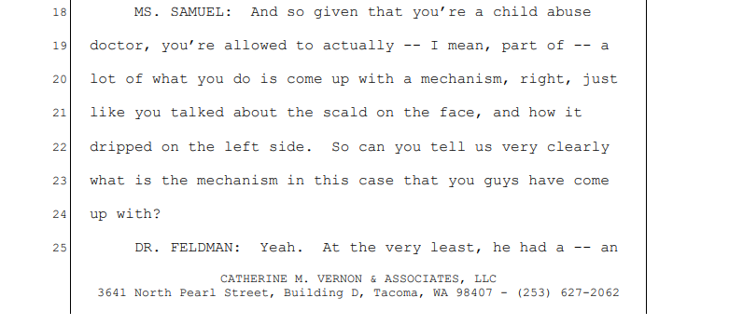
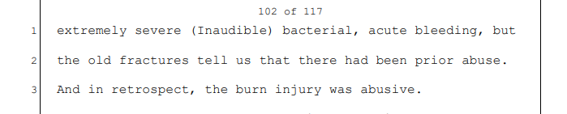
Defense Interview of Dr. Feldman, P. 101-02. By way of history, when M.Z.H.-A. first went to Seattle Children’s Hospital, the majority of the doctors, including Dr. Feldman, did not believe there was a burn at all on M.Z.H.-A.’s face. They believed he had a staph infection or a bullous impetigo. Dr. Boos indicated it could have been a burn, but the SCAN team did not believe it was. Even discharge summary notes that a burn was considered but discounted. Then, on November 29, 2017, approximately one week after being hospitalized, Dr. Boos again saw M.Z.H.-A. and stated he still believed the infection to actually be a burn, though he did state, given the presentation of M.Z.H.-A. and his parents, that he believed it likely unintentional. Only then did Dr. Feldman reconsider the possibility that this was a burn. Dr. Feldman and others did not see M.Z.H.-A. again until he passed away. Now claiming a burn, they speculated it was likely an immersion burn, then changed their speculation to possibly force feeding a thick, viscous liquid while M.Z.H.-A.’s face was tilted up- claiming M.Z.H.-A.’s face showed flow patterns. Tellingly, however, the inside of M.Z.H.-A.’s mouth is free from any burn. Their belief is that if there was any sign of abuse, then everything was abuse.
Defense experts, in their various reports, challenge a finding that this is even a burn. Dr. Freeman specifically notes that M.Z.H.-A. tested positive for staph while at Seattle Children’s Hospital. Dr. Freeman further noted:
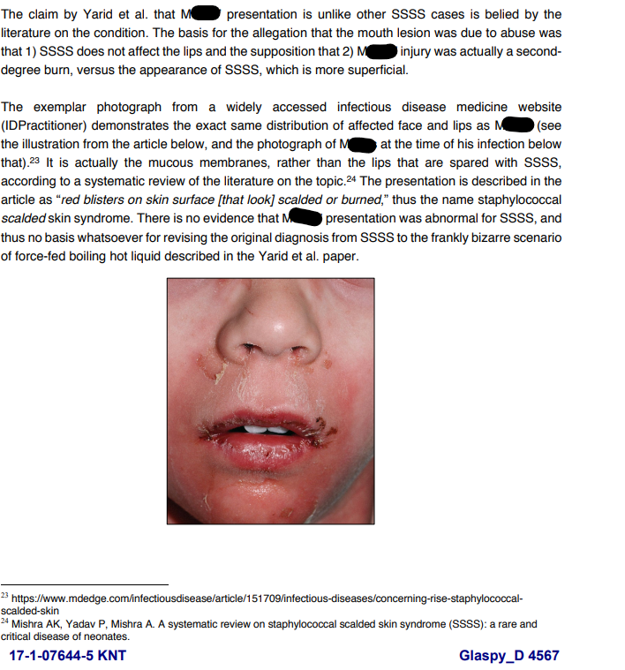
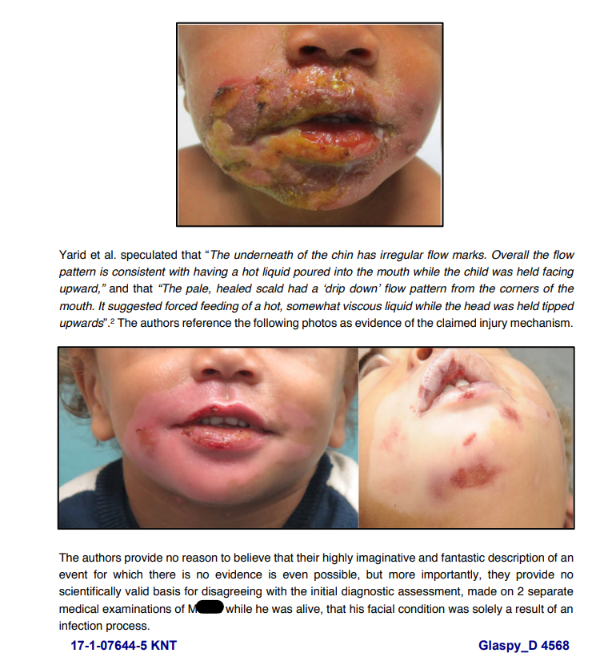
With the ever-changing diagnosis from the State’s witnesses, ignoring other patches of similar scabbing on M.Z.H.-A.’s other body parts, including, his neck, back, and arm, the shocking confirmation bias shown by Dr. Feldman, and the contested evidence from Dr. Freeman, the State cannot show that this was a burn by a preponderance of the evidence.
Further, as noted above, there would be no purpose to this evidence at trial. It is not relevant. Dr. Boos saw M.Z.H.-A. a week after his initial hospital discharge and noted that the infection had healed. Ms. TeAnna Ausler stated she was told that Dr. Boos was surprised that M.Z.H.-A. had healed so quickly. M.Z.H.-A. was ultimately discharged with no more follow ups with Dr. Boos needed. There is no claim by either side that this infection or, if the Court believes the State’s evidence, burn, had any impact at all on M.Z.H.-A.’s ultimate death. It would merely be introduced to showcase that Mr. Glaspy has a propensity for abusing children. As Dr. Feldman said, when he looked at the autopsy, he saw everything as a sign of abuse, despite other evidence to the contrary. Introducing this evidence, which serves no purpose, would simply ask the jurors to do the same: see Mr. Glaspy as someone who is abusing M.Z.H.-A. This cannot be allowed. This would also create a trial within a trial – many of the witnesses in this case are from Seattle Children’s Hospital to merely discuss M.Z.H.-A.’s skin infection that occurred at least 12 days before his passing. Exclusion of this irrelevant evidence would dramatically speed the trial up and save needless delay on an issue not relevant to cause of death.
    - Motion to exclude any reference to R.K. incident. The State cannot show it occurred and was linked to Mr. Glaspy by a preponderance of the evidence, it is irrelevant and serves no purpose, and it is more prejudicial than probative.

In 2014 Mr. Glaspy was home with his girlfriend’s children when one of them fell down and appeared injured. The child had a severely swollen head and was hospitalized. Child Protective Services, King County Sheriff’s Office, and the King County Prosecutor investigated this case. No charges were ever filed against Mr. Glaspy. CPS also cleared Mr. Glaspy. CPS determined that the child’s mother, Amanda Dodd, had caused the injury to R.K. because a second, older child, T.K., who also had marks and bruises on him, stated that his mother was the one who hit them and caused injury. BA 3725.
First, CPS, in their investigations, uses the same standard of proof that this Court must apply in a 404(b) context: preponderance of the evidence. WAC 110-30-0020, the definitions section of the Child Protective Services WAC note that “founded” means that “it is more likely than not that child abuse or neglect did occur”, “unfounded” means “the determination following an investigation by CPS that based on available information it is more likely than not that child abuse or neglect did not occur. . .”.
Here, CPS sent Mr. Glaspy a letter stating that the allegations against him were unfounded. BA 2150. The letter notes “erroneous – no finding” but then goes on to describe what unfounded means and begins by telling Mr. Glaspy that they “made a finding that no abuse or neglect occurred.” Id. Beyond this, the King County Prosecutor’s Office, Carla Carlstrom, using a lower, probable cause standard, found that that the case was “legally insufficient” because “we are unable to determine how the injury to R.K. occurred or who inflicted injury and are declining to file charges.” BA 76-77.
Further, CPS made a specific finding that Amanda Dodd caused this injury: “The findings of physical abuse and negligent treatment of maltreatment of R.K. and T.K., by their mother, Amanda Dodd more likely than not, did occur; the findings are FOUNDED.” BA 3110. This finding was made because T.K., the older child stated “oh sorry mommy did that” and “mommy did it” while pointing to bruises on his and R.K.’s body. T.K. made these statements to various SCAN team doctors and others at Seattle Children’s Hospital. Id.
Here, the State cannot meet the Norlin standard that there is a preponderance of evidence linking Mr. Glaspy to this alleged incident. State v. Norlin, 134 Wn.2d at 576-77. Rather, there is a preponderance of evidence linking the injury to Amanda Dodd, as noted definitively by CPS.
Again, as noted above, this allegation serves no purpose other than to be pure propensity evidence. It would be shown solely to indicate that Mr. Glaspy is a person who abuses children, and thus, is inadmissible under ER 404(b).
11. Motion to redact irrelevant content and ER 404(b) material prior to publication if admitted into evidence.

Granted Denied Reserved
If the State intends to admit any documents pursuant to ER 404(b), the Court must determine if those documents need to be redacted before being submitted to the jury. ER 403; Rice, 48 Wn. App. at 14. Additionally, references to other court cases and anything having to do with the criminal justice system must be redacted from any and all materials presented to the jury and/or admitted into evidence. Id.
12. Motion to exclude Mr. Glaspy’s prior convictions and any uncharged criminal acts if any exist.

Granted Denied Reserved

Defense has not been made aware of any criminal history or any uncharged criminal acts. In balancing probative value and prejudicial value, this Court should consider the necessity for the evidence. An uncharged or charged crime is not admissible merely because it is relevant. ER 402. For example, when the State’s case is weak, the probative value of other acts evidence is greater. See State v. Sexsmith, 138 Wn. App. 497, 157 P.2d 901 (2007); State v. Boggs, 80 Wn.2d 427, 495 P.2d 321 (1972). Furthermore, “[i]n a criminal case in which the evidence is being offered against the defendant, any doubt should normally be resolved in favor of excluding the evidence.” K. Tegland, Courtroom Handbook on Washington Evidence, § Ch. 5 pg. 258 (2011-12); State v. Myers, 49 Wn. App. 243, 742 P.2d 180 (1987).
Admitting the other acts is essentially admitting character evidence. It is impossible for Mr. Glaspy to receive a fair trial if the other acts are admitted. Even admitting some of other acts is highly likely to result in a conviction not based on the facts of the case, but based on the unfairly prejudicial impact other criminal allegations/convictions will have on the jury. The maxim “once a thief always a thief” is pervasive within our society and one which highlights the specific and real prejudice that occurs when other acts evidence is admitted. No limiting instruction can negate the unfair influence inherent in hearing about other acts.

The significant danger is that the State may be moving to admit other offenses that are similar to the current offenses that Mr. Glaspy is facing at trial. Tegland expressed this danger.

“In other words, a defendant’s misconduct, not charged in the present case, is not admissible to demonstrate the defendant’s general propensity for misconduct. For example, in a prosecution for assault, the defendant’s previous assaults on the victim or others would ordinarily be inadmissible as proof that the defendant assaulted the victim on the occasion in question.”

K. Tegland, Courtroom Handbook on Washington Evidence, § Ch. 5 pg. 241 (2011-12). Mr. Glaspy should be tried on the current charges not the other misconduct. Admitting this evidence would “…generate heat instead of diffusing light…where the minute peg of relevancy will be entirely obscured by the dirty linen hung upon it.” State v. Goebel, 40 Wn.2d 18, 23, 240 P.2d 251 (1952).

13. Motion to preclude State from eliciting "character evidence" of the defendant, ER 401, ER 402, ER 403, ER 404(a), ER 405.

Granted Denied Reserved
The defense moves in limine to preclude the State from eliciting any character evidence of the defendant from any witness called at trial. The State has not specifically indicated that it would be seeking to elicit such testimony concerning Mr. Glaspy’s reputation, however, a number of the State’s witnesses including Detective Marylisa Priebe-Olson and Jonathan Harris describe Mr. Glaspy as scary or intimidating to them given his size. These statements speak only to the personal biases, be they conscious or unconscious, of these witnesses. Such testimony has no probative value toward the allegations leveled here, is merely character or propensity evidence, and would do nothing but inflame the passions of the jury or move them toward an irrational and emotions-based approach to this case. Put simply, if they believed him to be scary because he is a large black man, that is irrelevant.
ER 401 defines relevant evidence as that having any tendency to make the existence of any fact that is of consequence to the determination of the action more or less probable than it would be without the evidence. ER 402 reminds us that evidence which is not relevant is not admissible.
Per ER 404 (a) and ER 405, should the State elect to offer evidence of the defendant’s character the evidence must be “pertinent” to prove the nature of the charges against the defendant. Specific instances of conduct are allowed only when that character trait of a person is an essential element of the charge, claim or defense.
Mr. Glaspy’s character is not at trial in this case. That law enforcement officers have experience with Mr. Glaspy from their investigation of this case and have made their own personal judgments about him is entirely irrelevant, and, given the special status law enforcement officers have in our society, would likely sway the jurors to believe such statements and opinions and cloud their judgments as to the strength of the substantive evidence discussed at trial.
Beyond this, Washington courts have long held that it is impermissible for a witness to opine on the veracity or believability of another witness. ER 608 provides that no witness may opine on the veracity of another. ER 608 also precludes a witness from opining as to whether a witness was "mistaken" or should be "believed." Tegland, Courtroom Handbook on Washington Evidence, 2007-08 Edition, p. 302-03. Further, ER 405 sets forth the only method permitted for proving the character, including reputation, of an individual, which cannot be met here, and thus such testimony should be excluded.
14. Law enforcement and lay witnesses should be barred from testifying as to their belief of Mr. Glaspy’s guilt.

Granted Denied Reserved
Witnesses, particularly law enforcement witnesses, may not testify about whether or not they believe a defendant is guilty, whether directly or by inference. State v. Montgomery, 163 Wn.2d 577, 594, 183 P.3d 267 (2008). This testimony is improper because it impedes upon the province of the trier of fact due to the “aura of reliability” surrounding law enforcement testimony. Id. at 595.
Here, any testimony from investigating officers that such officer had probable cause to believe that Mr. Glaspy had committed the offense charged should be barred. Such testimony would invade the province of the jury and constitute an improper comment on the evidence. Montgomery, 163 Wn.2d at 594-95. Further, any evidence or testimony that Ms. Glaspy was placed in cuffs and taken to jail is similarly inadmissible due to the extreme prejudicial effect such evidence would have on Ms. Glaspy. Any opinion by a law enforcement officer on an ultimate question of fact for the jury would be incompetent and prejudicial. ER 701, 403. Finally, such testimony is irrelevant to the case at hand, and thus should be inadmissible. ER 401, 402.
Similarly, lay witnesses may not opine as to the guilt of a criminal accused. State v. Jonson, 152 Wn. App 924, 934, 219 P.3d 958 (2009). A lay witness testifying about the guilt of a defendant invades their right to a fair and impartial trial. Id. Such error is of constitutional magnitude. Id. Here there is a substantial risk that the lay witnesses of the State will comment on their belief that Mr. Glaspy is guilty. Based on interviews, it is clear that Shannon Schultz, Jonathan Harris, TeAnna Ausler, and even members of the medical team, have been informed or told that Mr. Glaspy committed a murder. They all stated unequivocally that members of law enforcement or the prosecutor’s team have told them that evidence shows that Mr. Glaspy was responsible for the death of M.Z.H.-A.. The Court should instruct these witnesses to not discuss their personal beliefs of Mr. Glaspy. It would be improper because it is irrelevant. Id., ER 401. Further still, there is a strong risk that if the non-expert witness medical witnesses testify to being told that Mr. Glaspy was responsible for the death of M.Z.H.-A., that it will give an air of credibility to their statements given their role as medical doctors which would be improper – they are fact witnesses, not experts.
15. Law enforcement is barred from testifying about other contact with Mr. Glaspy

Granted Denied Reserved
This Court should preclude any testimony concerning contacts with Mr. Glaspy by law enforcement officers on any prior or subsequent matters, criminal or otherwise, other than in relation to the present charges. Any such testimony is likely to inflame the passions of the jury and make them believe Mr. Glaspy has a propensity to commit crimes. Thus, the prejudicial effect of such testimony substantially outweighs any probative effect it may have. ER 403. Finally, this testimony does not make a fact at issue in this case more or less probable and is thus irrelevant and inadmissible. ER 401 & 402.
Defense Counsel does not believe that any of the associated law enforcement officers were familiar with Mr. Glaspy, who has no criminal history, prior to this incident. Still, it is important to preclude such testimony should it exist.

16. Motion to exclude the State and its witnesses from vouching for anyone’s testimony or statements as it impermissibly invades the province of the jury.

Granted Denied Reserved
Improper vouching generally occurs (1) if the prosecutor expresses his or her personal belief as to the veracity of the witness or (2) if the prosecutor indicates that evidence not presented at trial supports the witness's testimony. United States v. Brooks, 508 F.3d 1205, 1209 (9th Cir.2007) citing United States v. Hermanek, 289 F.3d 1076, 1098 (9th Cir.2002)). “It is misconduct for a prosecutor to state a personal belief as to the credibility of a witness.” State v. Warren, 165 Wn.2d at 30, 195 P.3d 940 (citing State v. Brett, 126 Wn.2d at 175, 892 P.2d 29). Whether a witness has testified truthfully is entirely for the jury to determine. Brooks, 508 F.3d at 1210 (quoting United States v. Ortiz, 362 F.3d 1274, 1279 (9th Cir.2004)). Cross examination designed to compel a witness to express an opinion as to whether other witnesses were lying constitutes misconduct. State v Stover, 67 Wn.App.228, 230 (1992).
It is highly improper for any witness to vouch for their own or for another’s credibility. Whether a certain witness is credible is for a jury or a fact finder to determine. All statements of this nature must be prohibited at trial because it invades the province of the jury.

Motion to Exclude Specific Evidence and Specific Witnesses
17. Motion to exclude speculation regarding sexual assault and/or anal injury of M.Z.H.-A.

Granted Denied Reserved
Throughout the autopsy and at various other points throughout this case, Dr. Yarid and Dr. Feldman speculate about M.Z.H.-A. being sexually abused and/or anally penetrated. This speculation led to them requesting WSP Crime Lab analyze M.Z.H.-A.’s anal swabs for signs of DNA or semen. Upon examination, there was no semen or DNA found in these anal swabs other than M.Z.H.-A.’s own DNA – despite Analyst Hugie’s agreement that DNA can and does transfer easily from person to person.
At interview, Dr. Yarid, Dr. Feldman, and Analyst April Hugie each made statements surrounding the tearing and bleeding around M.Z.H.-A.’s anus. Dr. Yarid indicated “I don’t know” when asked if the injury was penetrative in nature. Defense Interview of Dr. Yarid, Pt. 1, P. 63-64. Ln 24-25; 1. When asked if penetrative injury was the primary possible cause of the injury Dr. Yarid responded “Um, I don’t know.” Id. at p. 64, ln 5-7. Dr. Yarid further noted that she did not find any laceration or injury to the inside of the anus. Defense Interview of Dr. Yarid Pt. 4; P. 57, ln 18-22. More tellingly, Dr. Feldman, in his interview stated that M.Z.H.-A. “clearly had the perianal injuries, but we could not say with certainty whether that was sexual abuse, or not.” Defense Interview of Dr. Kenneth Feldman, P. 102, ln 15-17. Further, in a deposition in a related civil suit, Dr. Feldman stated that he did “not really” have an suspicion one way or the other that M.Z.H.-A. was sexually assaulted:
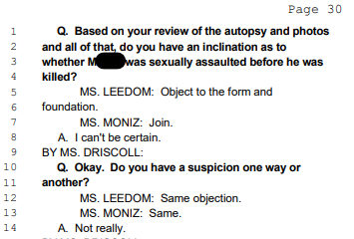

BA 6687.
Finally, Analyst Hugie, in her interview repeatedly stated that determining if there was sexual assault that occurred to M.Z.H.-A. would be “things outside of what I can say”, Defense Interview of April Hughie, P. 41, ln. 24-25. She further noted that while people including prosecutors at trial will ask her about if a sexual assault occurred based on her findings, she agreed “it’s – on my part, it’s speculation . . .” Id. at ln 17-18. She agreed that any answer on that point would be civilian speculation. Id. at P.42, line 3-6.
This extremely prejudicial speculation should be excluded under ER 401, 402, and 403. In the context of joinder, State v. Sutherby, noted the extreme prejudicial effect of sex offenses when discussed with other allegations. 165 Wn.2d 870, 884, 204 P.3d 916 (2009). The Sutherby Court noted that “there is a recognized danger of prejudice to the defendant even if the jury is properly instructed. . .”. Id. Here, the danger of allowing doctors to speculate that M.Z.H.-A. may have been sexually assaulted, despite the dearth of evidence would do nothing but inflame the passions of the jury. One can think of few allegations more heinous than sexually assaulting a toddler and then murdering them, and if told that there was speculation of this, the jury would likely be overcome by their passions and convict solely on their outrage and disgust, rather than carefully evaluating evidence. This speculation provides no probative value to the case, especially as such alleged injury does not touch on the State’s claimed mechanism of death. Any testimony of this speculative nature should be excluded. ER 401, 402, 403.
18. Motion to exclude speculation regarding shaking, shaken baby syndrome (SBS) or abusive head trauma (AHT).

Granted Denied Reserved
Throughout this case, State’s witnesses have at times hinted that there may have been shaking in this case. They have, as time went on, backed off of this allegation. Dr. Yarid, in her interviews with Defense, specifically disclaimed shaking as a mechanism in this case: “I’m not implying shaken.” Defense Interview of Dr. Yarid Pt.3 P. 16, ln. 5. Further, in open court during a pretrial hearing in front of the Honorable Andrea Robertson, Ms. Gevers noted something to the effect of “there is no credible evidence to suggest shaking in this case.” Still, Defense requests an order to not allow State witnesses to discuss or speculate that this may somehow be a shaking case. As above, there is a risk of extreme prejudice based upon speculation that there may be shaking in this case. These are loaded terms that conjure gruesome images in the mind of jurors. Without evidence to suggest it may have occurred, there is no probative value to such testimony and the risk of unfair prejudice is high. Any references to this by the State should be excluded. ER 401, 402, 403. Finally, if this were to be allowable as relevant, it would run afoul of discovery orders in this case, as this mechanism of injury was not disclosed as a topic to be opined on by State witnesses.
19. Motion to exclude late disclosed witnesses – Eric Timm and Jim Stevens

Granted Denied Reserved
Defense requests that pursuant to CrR 4.7, CrR 8.3(b), and the discovery orders entered in this case, that the Court exclude witnesses Eric Timm and Jim Stevens from testifying in this case.
The State sent along one formal witness list, dated April 28, 2020. Appendix X. This list did not list witnesses Eric Timm and Jim Stevens. April 7, 2021, Defense requested a list of witnesses who may need prosecutor presence for interviews. Appendix X. Again, Eric Timm and Jim Stevens did not appear on this list. Defense filed a Discovery Motion on August 15, 2022, which was heard and argued in front of Judge Robertson. As part of this request, Defense requested witness statements as required by CrR 4.7 The Court granted the motion in part on August 18, 2022, noting that both sides needed to comport with CrR 4.7. To date, Defense has not received a summary of testimony of witnesses Eric Timm or Jim Stevens. After that August hearing, the State did not file an amended witness list – leaving Defense with only the April 28, 2020 list. The State did not disclose these witnesses to Defense until November 23, 2022:
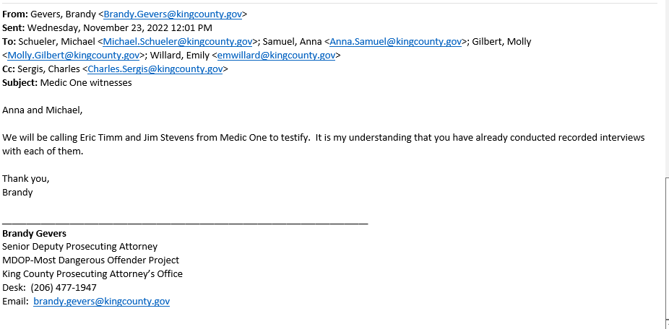
This email was sent 9 days after the omnibus order was entered, and 5 days after the amended omnibus order was entered (simply clarifying due dates on pretrial motions).
CrR 4.7(a)(1) controls the discovery obligations of the prosecutor. CrR 4.7(a)(1)(i) requires that the prosecutor “disclose to the defendant the following information . . . no later than the omnibus hearing: the names and addresses of persons whom the prosecuting attorney intents to call as witnesses . . . together with any written or recorded statements and the substance of any oral statements . . .” This was violated.
CrR 4.7(i), (ii) control the sanctions for failure to comply with orders of the Court and this rule. The rule permits the Court to “grant a continuance, dismiss the action, or enter such other order as it deems just under the circumstances.” CrR 4.7(7)(i). If the Court finds a willful violation, it can also sanction the lawyers personally. CrR 4.7(7)(ii).
State v. Mora-Lopez, 22 Wn. App. 2d 922, 514 P.3d 714 (2022) is instructive on this issue. In Mora-Lopez the Court ruled that where the State “failed to file and serve its witness list until four business days before the trial” it “violated CrR 4.7 . . . the trial court’s oral ruling during the omnibus hearing requiring the parties to provide witness lists by the end of the day, and the agreed written omnibus order . . .” Id. at 929. The Court further noted that:
While the State argues that its initial discovery included all the names ultimately included on its witness list, the witness list contained only a subset of the individuals identified in its discovery materials. Moreover, the identifications included in the initial discovery did not comply with the requirements of CrR 4.7(a)(1)(i), including address and substances of statements.
Id. at 929-930. This constituted mismanagement under CrR 8.3(b). Id. at 927. The Court, however, ruled that dismissal was inappropriate as there was not a time for trial violation and thus no prejudice (as required for dismissal under CrR 8.3), noting that lesser remedies would have ameliorated the problems. Id. at 932-33.
Here, for these violations, Defense is not seeking dismissal, but rather the lesser remedy of exclusion under either CrR 4.7(7) or 8.3(b). Here, the facts are similar – the disclosure of the two witnesses came on November 23, 2022, excluding the holiday and weekends, five days before trial was set to commence. The State clearly violated the orders of the Court from August 18, 2022, did not file any additional witness list (and, like in Mora-Lopez, their list was less inclusive than all of the names appearing in discovery), and violated the plain language of CrR 4.7(a)(1)(i). At best, this implies that the State was not seriously considering its case until the very eve of trial – shocking when we consider that this case is five years old. Such disregard for the rules, as noted in Moya-Lopez is misconduct and mismanagement, and the lesser remedy of exclusion of these witnesses is warranted, metered, and appropriate for this clear violation of discovery.
20. Motion to exclude late disclosed photographs and/or redact them

Granted Denied Reserved
Similar to the above, in a separate email 10/23/2022, the State sent along 14 in life photographs of M.Z.H.-A. with Ms. Shultz and Mr. Harris. These late disclosed photographs likely violate CrR 4.7, as noted above. They also are irrelevant as they (a) do not show dates or times when they were taken and (b) contain no metadata to help ascertain dates and times taken – they are merely screenshots of what appears to be Facebook images. ER 401, 402.
If the Court, however, declines to exclude these photographs, it must redact them. There are text overlaid on the photos expressing the sadness that, presumably, Ms. Schultz feels for the loss of her grandson. This text has no relevance and is more prejudicial than probative as it seems designed to tug the heartstrings of the jury. ER 401, 402, 403. Further, there is no way to tell who added the text and/or when it was added, highlighting the additional irrelevance of it. At the very least, the text should be redacted from the photos, if they are to be admitted at all.

21. Motion to exclude specific items seized.
Granted Denied Reserved
- Items found in the Willow Lakes Apartment
Defense anticipates that multiple witnesses may testify about bongs and other marijuana paraphernalia, as well as a handle less knife and a lighter found in the Willow Lakes apartment of Mr. Harris and Ms. Schultz. This evidence is irrelevant to the charges here and extremely prejudicial while providing no probative value at all. ER 401, 403. Such evidence would serve only to paint Mr. Glaspy in a negative light. “Unfair prejudice” in the context of ER 403, “speaks to the capacity of some concededly relevant evidence to lure the fact finder into declaring guilt on a ground different from proof specific to the offense charged.” Old Chief v. United States, 519 U.S. 172, 117 S.Ct. 644, 650, 136 L.Ed.2d 574 (1997). That ground is “commonly, though not necessarily, an emotional one.” Id.
22. Motion to redact portions of videos.
Granted Denied Reserved
Should the State intend to play or offer any audio or video recordings of any witnesses as substantive evidence in its case in chief, Defense requests that portions of the recorded interviews other than Mr. Glaspy’s, in this case be redacted. Throughout the recordings there are sections of officers relating hearsay statements, discussing their belief that Mr. Glaspy was guilty, and witnesses similarly opining. Such statements are inadmissible hearsay, irrelevant, and unfairly prejudicial. ER 803, 401, 403. Counsel would request that at the start of motions the parties review any video/audio recordings on the record and identify specific objections in order to ensure accurate redactions.
23. Motion to exclude gruesome and unnecessary photographs.
Granted Denied Reserved
The admission of photographs is within the sound discretion of the trial court. State v. Gentry, 125 Wn.2d 570, 608 (1995); State v. Pirtle, 127 Wn.2d 628, 651 (1995); State v. Crenshaw, 98 Wn.2d 789, 807 (1983); State v. Sargent, 40 Wn. App. 340, 347 (1985). “A bloody, brutal crime cannot be explained to a jury in a lily-white manner”. State v. Adams, 76 Wash.2d 650, 656 (1969). The fact that a crime scene or autopsy photograph may have some probative force is not always completely determinative of its admissibility. There are cases where the logical relevance of such an exhibit will unquestionably be overwhelmed by its inherently prejudicial qualities, which will impair the defendant’s right to a fair and impartial trial. Crenshaw went on to assert that:
“[n]evertheless, we take this opportunity to warn prosecutors that we look unfavorably on the admission of repetitious, inflammatory photographs. Prosecutors as well as trial courts must exercise their discretion in the use of gruesome photographs. The statement that “the State had the right to prove its case up to the hilt in whatever manner it chose,” must be read to mean only that the State may present ample evidence to prove every element of the crime. Prosecutors are not given a carte blanche to introduce every piece of admissible evidence if the cumulative effect of such evidence is inflammatory and unnecessary. In other words, in such situations where proof of the criminal act may be amply proven through testimony and noninflammatory evidence, we caution prosecutors to use restraint in their reliance on gruesome and repetitive photographs.”

Crenshaw, 98 Wn.2d at 807. Finally, Sargent expressly cautioned prosecutors against submitting “inflammatory and unnecessary” photographic evidence. 40 Wn. App. at 340.
Here, the State, through Dr. Yarid, claims that M.Z.H.-A. died from blunt thoracic injury from kicking, punching, squeezing, slamming, or some other similar manner. As part of the death investigation, detectives and medical examiner personnel took hundreds of photographs of M.Z.H.-A., both at the scene and at autopsy. These photos are tragic, graphic, and extremely difficult to look at. Some of these photos are likely duplicative and unnecessary to explain the State’s theory as to what happened. Defense requests that the Court order the State to provide the precise photos it intends to use and introduce, as well as for what purpose, so that the Court can determine if the photographs are duplicative or unnecessary.
24. Motion to exclude Dr. Richard Harruff
Granted Denied Reserved
Simply put, Dr. Harruff did nothing in this case. Dr. Harruff is the chief Medical Examiner and Dr. Nicole Yarid’s supervisor. Dr. Yarid, in a deposition given in a related civil suit – a deposition that she did not disclose in her Defense interview despite being asked – stated that Dr. Harruff “did not participate in the autopsy.” She noted that the only reason his name was on the autopsy report was in case “I wasn’t employed here anymore, that he could testify on my behalf.”:
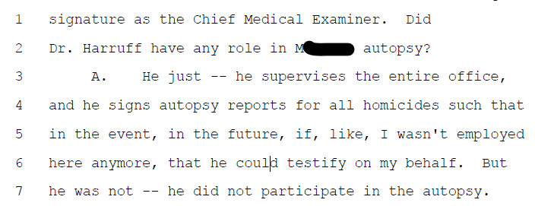
Dr. Nicole Yarid Civil Deposition, P. 8, ln 1-7. Further, in his Defense interview, Dr. Harruff, when asked if he “contributed even one word to the autopsy report” stated “Uh, no, I don’t think so.” P. 17, ln. 19:
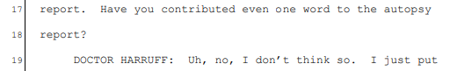
He further stated “So I don’t have anything further to add other than, just sort of – and that’s the word you used, cumulative. . .”; “Well, here – here’s what I would say if I’m called to testify. One word. Why?” Defense Interview, P. 42-43:
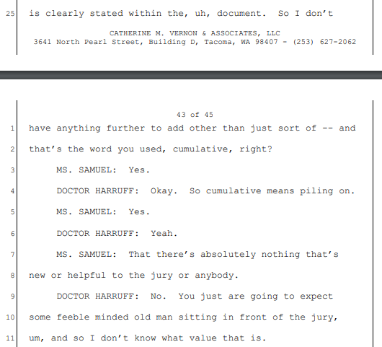
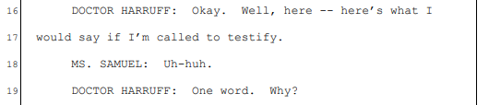

He had no notes retained and could not recall specifically what he did on the case – agreeing with the question from Defense that he did not “have a strong recollection one way or the other what sections of the autopsy or what histologic slides you specifically reviewed.” Defense Interview, P. 12, Ln. 4-9. His sole purpose would seem to be to bolster the opinions of Dr. Yarid: “But she’s, uh – her thoroughness and accuracy are pretty intimidating. I wouldn’t want to disagree with her on many things so because, you know, she – she does a really thorough job.” Defense Interview, P. 13, Ln 16-20.
Admissibility of a witness under ER 702 turns on if “(1) the witness qualifies as an expert, (2) the opinion is based upon an explanatory theory generally accepted in the scientific community, and (3) the expert testimony would be helpful to the trier of fact.” State v. Rafay, 168 Wn. App. 734, 784, 285 P.3d 83 (2012) (quoting State v. Ciskie, 110 Wn.2d 263, 271, 715 P.2d 1165)). Even if the ER 702 test is satisfied, trial courts have discretion to limit or exclude testimony under ER 403 if there a danger of unfair prejudice. Ciskie, 110 Wn.2d at 279. The trial court “necessarily has broad discretion in determining whether expert testimony should be admitted under ER 702, and” any decisions of the trial court will be reversed “only if it is based on unreasonable or untenable grounds.” Rafay, 168 Wn. App. At 783-84 (citing In re Anderson, 166 Wn.2d 543, 549, 211 P.3d 993 (2009)).
Dr. Harruff should be excluded as a witness under both ER 702 and ER 403 analysis. First, under ER 702, Dr. Harruff’s testimony would not be helpful to the trier of fact. He does not recall what, if anything, he did in this case. He has no opinions other than he believes Dr. Yarid is thorough. He stated he would ask “why” if he was called to testify and that he contributed nothing to the autopsy in this case. Dr. Yarid went further, noting that he did not participate in the autopsy. His testimony, thus, would be simply bolstering without substance. It would do nothing to help the jury ascertain the truth in this case. Further, under ER 403, Dr. Harruff’s testimony would, in his own words, be cumulative. ER 403 notes that if the probative value of something is substantially outweighed by the danger of unfair prejudice, “or by considerations of undue delay, waste of time, or needless presentation of cumulative evidence” such evidence may be excluded. Here, there is a risk of unfair prejudice in Dr. Harruff vouching for the excellence of Dr. Yarid without being able to cite to any specifics, and because anything he could say would be merely, at best, duplicative to what Dr. Yarid would say. His testimony should be excluded.
25. Motion to exclude Dr. Kenneth Feldman as cumulative.
Granted Denied Reserved
Similar to Dr. Harruff being a merely cumulative witness, Dr. Feldman is also a cumulative witness. He did not actually examine M.Z.H.-A. when he was alive. He did not conduct an autopsy. He, rather, served in a speculative consulting role, stating that his role was “consulting with the caretaking physician.” Defense Interview of Dr. Feldman, P. 68, ln. 10-11. The crux of his testimony seems to be to describe an alleged burn pattern – a pattern he initial stated was not present, and to speculate on mechanism of injury to M.Z.H.-A., such as blows to the chest, squeezing, kicking, punching, etc. When asked specifically what he intended to add to the case, Dr. Feldman stated “I think I expressed my legal opinions when – how I collaborated with the , uh, prosecutors and (inaudible) medical exam, and was at that conference.” Id. at P.112, ln 1-4. When pressed further about what he specifically did, Dr. Feldman agreed that he did not conduct any testing, did not participate in the autopsy other than watch, and that his expertise in “accident versus abuse” “seems to be very different from what a non-medical observer could bring to the, uh, situation.” Id. at P. 112, ln 23-25; P. 113, ln. 1-2.
None of this proposed evidence or testimony from Dr. Feldman is helpful to a trier of fact under ER 702 and is cumulative under ER 403 because it will be touched on by subject matter experts such as a dermatologist – Dr. Markus Boos – and a forensic medical examiner, Dr. Nicole Yarid. These two doctors can specifically discuss all of areas of ‘expertise’ that Dr. Feldman has, and, unlike Dr. Feldman, had direct contact with M.Z.H.-A. or conducted testing/autopsy on him personally. Dr. Feldman, thus, just serves to bolster other witnesses by effectively stating he too, concurs that abuse occurred. This is unhelpful to a jury in light of more specific expert testimony, and further, is nothing more than cumulative evidence wearing a lab coat with a medical degree. His testimony should be excluded.
26. Motion to preclude Dr. Yarid article “Cardiac Ventricular Laceration Due to Child Abuse: Abusive Ventricular Laceration” from being admitted to the jury.
Granted Denied Reserved
Dr. Yarid and other State witnesses wrote an article detailing their findings in this case. Defense is specifically requesting this article not be allowed to go back as an exhibit to the jury because there are factual issues with the article, it discusses potential defense strategies, ways to avoid having evidence excluded, would be cumulative to the testimony of the witnesses, and, would amount to playing back portions of testimony – highlighting the opinions of the State’s witnesses over other witnesses.
First, the article contains some factual inaccuracies. It notes that M.Z.H.-A. was cold when found. This is disputed by a number of witnesses. It seems to imply M.Z.H.-A. was dead for a long period of time, which, given the FaceTime call approximately 30 minutes before the 911 call(something which was unknown to the article authors when it was written) is untrue. Further, it states that the SCAN team was unaware of the initial opinion of Dr. Boos, that M.Z.H.-A. had a burn. This was untrue as it appears that the Children’s Hospital Network was integrated such that the various doctors involved should have been able to see each other’s reports.
Next, the article contains a section about courtroom procedures. The article states “[s]hould this case go to court, it will provide a more acceptable, but still vivid image to a judge or jury of the pericardium hemorrhage than would the open chest at autopsy. It is less likely to be excluded from evidence due to defense objection, as inflammatory.” BA 2650. This section is wholly irrelevant to any opinion and implies that Defense would try to hide evidence. It is an impermissible comment on counsel. ER 401, 402, 403.
Finally, introducing the article to the jury would be cumulative under ER 403 as it contains the opinions of the other testifying doctors – Dr. Yarid, Dr. Otjen, and Dr. Boos – and also would be akin to allowing the jury to replay one small portion of testimony over and over each time they read it. Further, some of the State’s witnesses have disavowed certain language attributed to them in the article and/or claim minimal participation even though their names have been added to the article. Courts generally disfavor repeating trial testimony. In State v. Koontz, the Washington Supreme Court reversed a conviction where the jury was permitted to view videotapes of trial testimony by the defendant, child witness and daycare provider. 145 Wn.2d 650, 41 P.3d 475 (2002). The trial court replayed the taped testimony after the jury indicated it would be helpful to bring them out of their deadlock. Id. at 651. The trial court also replayed the entire testimony of all three witnesses in open court and instructed the jury not to unduly emphasize this testimony. Id. at 652.
In reversing, Koontz first noted that: “reading back testimony during deliberations is disfavored.” Koontz, 145 Wn.2d at 654, citing United States v. Portac, Inc., 869 F.2d 1288, 1295 (9th Cir. 1989). This is because the jury may place undue emphasis on testimony considered a second time at such a late stage in the trial. Id. The court then acknowledged that: “[r]eviewing videotaped testimony raises greater concerns than reading from a transcript because videotaped testimony allows the jury to hear and see more than the factual elements contained in the transcript.” Id. at 655. Thus, the court concluded that “the unique nature of videotaped testimony requires trial courts to apply protections against undue emphasis that consider both the effect and the manner of the video replay.” Id.
Koontz found that while the trial court did take some precautions (played videos in open court, properly instructed the jury), the trial court nonetheless failed to consider the improper effect of the video replay and none of the protections it employed could correct this failure. 145 Wn.2d at 659. Because the jury was not limited to discreet portions of testimony and it was looking for indications of credibility, “facial expressions and whatnot,” they were seeking an “improper repetition of the complete trial testimony of three critical witnesses.” Id. The court found the error was not harmless because it materially affected the outcome: there was no physical evidence that tied Koontz to the assault and the testimony that was replayed was directed at the central issue of whether Koontz had an opportunity to commit the assault. Id. at 660.
Similarly, United States v. Binder held that allowing the jury to replay a child victims’ videotaped testimony alleging sexual abuse by the defendant was an abuse of discretion. 769 F.2d 595 (9th Cir. 1985). There, the tape was played in the jury room and the court found that allowing the jury to see and hear the children a second time unduly emphasized that testimony. Id. at 601. Because no other witnesses corroborated the specific allegations and the defense was a denial of the charges, the court found that the error was not harmless. Id. at 602.
The State here may mistakenly rely upon State v. Castellanos to support its position that the article should go back to the jury. 132 Wn.2d 94, 935 P.2d 1353 (1997). Castellanos, dealt with a body wire tape that recorded the defendant making the purported drug transaction that was the subject of the prosecution. Id. at 96-7. The Court’s decision that the trial court properly replayed the tape for the jury was based on its conclusion that the tapes at issue were not testimonial because they were contemporaneous recordings of the drug transactions themselves. Id. at 102.
In this case, the article is not a contemporaneous recording of the incident itself but distilled and written opinions by the State’s primary and most critical witnesses – their expert witnesses. Castellanos does not support allowing the jury to have an article that would allow them to read and reread the critical and ultimate opinion of the State’s witnesses. for the jury. The various factors considered by the courts weigh heavily against allowing the jury to have this article. These witnesses, and the opinions contained within this article, are the only State witnesses with direct testimony incriminating Mr. Glaspy. To allow the jury to read over and over the opinion of the State’s doctors would permit them to continuously hear the State’s witnesses’ opinions while only hearing the Defense expert witness opinions once. Under the reasoning of Koontz and Binder, that would unduly emphasize the testimony of the State’s expert witnesses over the Defense expert witnesses. If the Court intends to allow this article into evidence, then each of the Defense reports must, at a bare minimum, also be admitted into evidence so the jury can consider them repeatedly as well.

Defense General Motions
27. Motion for a bill of particulars
Granted Denied Reserved
Defense raised and litigated a motion for bill of particulars in its Discovery Motion on June 23, 2022, ECR Sub. No. 198. This motion was denied by the Honorable Andrea Robertson. ECR Sub. No. 214, dated August 18, 2022. Defense is renewing that motion at this time in order to ensure it is preserved for any appeal. The argument made by Counsel is below.
Traditionally, defendants are charged by way of information so that they may be informed of the crime allegedly committed and thus be able to prepare for a defense. See, e.g. State v. Womack, 4 Wn. 19, 29 P. 939 (1982)
CrR 2.1(c) allows for a bill of particulars to be filed “before arraignment or within 10 days after arraignment or at such later time as the court may permit.” (emphasis added). The purpose of CrR 2.1(c) is to ensure that a defendant has notice of both the precise criminal charge and adequate notice of the prosecutor’s theory of how this offense was committed. See State v. Dictado, 102 Wn.2d 277, 286, 687 P.2d 127 (1984) (abrogated on other grounds); State v. Peerson, 62 Wn. App. 755, 767-68, 816 P.2d 43 (1991). Further, this rule ensures that the accused has “sufficient notice of the charge so he can completely defend against it.” Id. At 768.
A bill of particulars should be granted when it will aid the defendant in the preparation of his/her case. Dictado, 102 Wn.2d at 286. The bill of particulars should be granted so that an accused person has notice of the prosecution’s theory and can properly craft a defense thereto—a person accused of a crime has a “due process right to be tried only for stated offenses”. Peerson, 62 Wn. App. at 768. Finally, the purpose of a bill of particulars is to cure any vagueness in the charging instrument and amplify or clarify “particular matters essential to the defense.” State v. Holt, 104 Wn.2d 315, 321, 704 P.2d 1189 (1985).
Here, Mr. Glaspy is stuck guessing at to what specifically the State believes happened. Each doctor interviewed has a different interpretation as to how M.Z.H.-A. died – Dr. Feldman has written articles and given presentation alleging a blow to the chest, a squeeze, or a ruptured heart ventricle (thought that may be secondary to a blow or squeeze). Dr. Yarid, in contrast, appears to state that the cause of death could be those, but could also be blows to the head, internal injuries, or, in her most recent interview, potentially a result of shaking.
Further exacerbating the issues in this case is the issue of timing. Dr. Yarid seems to imply that some of the injuries, including potentially fatal injuries, could have occurred days or more before the date that M.Z.H.-A. was declared dead. This is important as a critical piece of the state’s theory seems to be that Mr. Glaspy was alone with M.Z.H.-A. at the time of death and thus was the likely person causing injury, but if the injuries could have occurred days earlier, then it would implicate strong other suspect evidence in the mother of the decedent, TeAnna Ausler, or her mother and step father, Shannon Schultz and Jonathan Harris. All three of these individuals have had Child Protective Services (CPS, now Department of Children, Youth, and Families, DCYF) involvement or allegations of abuse or neglect leveled against them.
A Bill of Particulars is necessary to cure the vagueness of the State’s allegations. Holt, 104 Wn.2d at 321. How the State believes M.Z.H.-A. died is of “essential to the defense.” Id. Without a Bill of Particulars, Mr. Glaspy is left playing a game of whack-a-mole between competing theories of how death occurred. Mr. Glaspy will be unable to ensure his experts are able to address the actual cause of death and explain how the State’s theory is incorrect. It is critical have this information to ensure that Mr. Glaspy is afforded constitutionally effective counsel and to prevent the ever-shifting diagnosis of M.H.A’s death to continue.

28. Motion to bar law enforcement from testifying in front of the jury as to any hearsay received from a 911 call, radio dispatch, fellow officers, or State’s witnesses with regard to the incident.

Granted Denied Reserved
Evidence rule 801(c) permits admission of statements that would otherwise be inadmissible as hearsay if they are not being offered for the truth of the matter asserted but for some other purpose. State v. Aaron, 57 Wn. App. 277, 280, 787 P.2d 949 (1990). In Aaron the Court of Appeals for Division I held that it constituted error to permit the investigating officer to testify to statements he learned from the police dispatcher regarding the type of clothing the defendant had in his possession near the time of the crime. Aaron, 57 Wn. App. at 279. The court rejected the State’s argument that the officer’s statement was not being offered for the truth but “to show the officer’s state of mind in explaining why he acted as he did.” Id. at 280. The court held:
If the legality of the search and seizure was being challenged, either at a suppression hearing or at trial, the information available to the officer as the basis for his action would be relevant and material. However, the officer's state of mind in reacting to the information he learned from the dispatcher is not in issue and does not make "determination of the action more probable or less probable than it would be without the evidence." ER 401. Accordingly, the dispatcher's statement was not relevant for another purpose.

Id.
The Aaron court recognized a case might arise where it might be necessary for an officer to testify to past facts and endorsed a specific solution. “As suggested by one commentator, if necessary at trial for the officer to relate historical facts about the case, it would be sufficient for him to report he acted upon ‘information received.’” Aaron, 57 Wn. App. at 281. This case, however, presents no such scenario. At risk here is that officers will relate what officers or medical personnel told them during the course of the investigation. Any such information would not be admissible as a statement made for medical diagnosis, as medics speaking to law enforcement are not doing so to render any medical aid. Such information is hearsay without exception and should be excluded.
29. Motion to exclude witnesses and to instruct witnesses to refrain from discussing any testimony directly or indirectly, pursuant to ER 615.

Granted Denied Reserved
In order to prevent violations of this Court's pretrial rulings, either voluntarily or involuntarily, the Court should order both the state and defense to inform their respective witnesses of the Court's rulings. Doing so will ensure that excluded evidence will not be heard by the jury and will help preserve the integrity of the trial process. ER 615
Defense moves to exclude witnesses from the courtroom until they have testified and moves for an order prohibiting witnesses and parties from disclosing the nature and substance of claims made in opening statement and witness testimony to other witnesses. ER 615. Further, Defense moves to preclude parties present in the courtroom from discussing the nature of testimony or proceedings with witnesses who have been excluded. ER 615 exists “to discourage fabrication or collusion among witnesses.” K. Tegland, Wash. Prac., Evidence Law & Practice, § 615:1 (2018-19 Ed.). Further, “Witnesses who are excluded should also be admonished by the court not to discuss the case with other witnesses or describe what occurred in the courtroom.” Id. (citing U.S. v. Buchanan, 787 F.2d 477 (10th Cir. 1986)). Thus, the witnesses should be admonished not to discuss any matters of this case amongst themselves to prevent collusion. Defense also requests that the State not inform one witness of the substance of another witness’s testimony.

30. Motion to order sitting officer to testify first to effectuate spirit of ER 615.

Granted Denied Reserved

Should the state elect to have a law enforcement officer sit with them at counsel table during the trial, Defense requests that this court order said officer to testify first in order to satisfy the spirit of ER 615. As noted above, ER 615 exists “to discourage fabrication or collusion among witnesses.” K. Tegland, Wash. Prac., Evidence Law & Practice, § 615:1 (2018-19 Ed.). The purpose of the rule is to ensure that a witness will not be swayed to testify in a particular manner based upon what other witnesses have said in court. Further, this Court has the “inherent authority to control and manage their calendars, proceedings, and parties.” State v. Gassman, 175 Wn.2d 208, 211, 283 P.3d 1113 (2012) (citing Cowles Pub’g Co. v. Murphy, 96 Wn.2d 584, 588, 637 P.2d 966 (1981)). Thus, in order to ensure that the spirit of ER 615 is effectuated, any sitting law enforcement officer should be ordered to testify first.

31. Law enforcement should be barred from reading their report into the record.
Granted Denied Reserved
Statements made in police reports are hearsay and are only admissible if a hearsay exception applies. State v. Garcia, 179 Wn.2d 828, 848, 318 P.3d 266 (2014). Because of this, it would be improper to allow a police report to be read into evidence because it would contain hearsay. ER 802.
In this case, it is likely that any officer testifying will need to refresh their recollection. While it is proper to allow an officer to refresh his or her recollection while testifying, ER 612, the officers should be barred from simply reading their report into the record because doing so would include hearsay statements. Garcia, 179 Wn.2d at 848; ER 802. Because there is no hearsay exception to the police report as a whole, allowing officer to simply read their report into the record would be improper. Id.
32. Motion to refer to parties by names.
Granted Denied Reserved
Defense asks the court to prohibit the State and its witnesses from referring to M.Z.H.-A. or anyone else as the “victims” and to Mr. Glaspy as “the suspect” or “the defendant” for the following reasons:
No witness may express an opinion as to the guilt of a defendant. St. v. Demery, 144 Wn. 2d 753, 759 (2001). The designation “victim” is, in effect, a determination of the legal status of the parties. The linguistic flip side of calling the complaining witness a “victim” during trial is that the defendant is a “victimizer,” which is effectively synonymous with a guilty person in the present case. Thus, the use of the term “victim” during testimony by police constitutes impermissible opinion evidence. It is also argumentative. Thus, its use should be prohibited by witnesses and the State attorney until closing argument.
The court should also prohibit reference to Mr. Glaspy as the suspect or the defendant in front of the jury during the entire trial. Mr. Glaspy is a person. He has a name. It is respectful to refer to him by his proper name. Calling him “the defendant” or “suspect” over and over again is objectionable for a variety of reasons. First, it depersonalizes him, which could have the effect of making it harder for the jury to accept his testimony or believe it. It could also make the jury less careful in its deliberations and more willing to convict.
Second, it is argumentative. Every time the State calls Mr. Glaspy “the defendant” it is shorthand for saying “that bad person over there who is guilty of this crime.” With enough repetition, jurors may come to believe that Mr. Glaspy is guilty for no other reason than the State would not keep saying it if it were not true. Calling Mr. Glaspy “the defendant” or “the suspect” has no probative value. It has significant prejudicial value. Consequently, the court should prohibit it in front of the jury pursuant to ER 402 and 403.
33. Motion to compel the prosecution to disclose any PowerPoint or other pre-produced materials to be used in opening or closing argument.
Granted Denied Reserved
Should the state seek to use a PowerPoint presentation or any similar visual aid during closing argument, it should be made available to Defense and the Court prior to trial to ensure that no inflammatory, misleading, or other statements amounting to misconduct are contained therein. See State v. Walker, 182 Wn.2d 463, 468, 341 P.3d 976 (2015); State v. Allen, 182 Wn.2d 364, 373-74, 341 P.3d 268 (2015) (prosecutor repeatedly misstated the proper definition for accomplice liability in a power slideshow accompanying closing argument).

34. Motion to exclude the Court from stating “the record shall reflect” should the state seek to identify Mr. Glaspy as the defendant because it is an impermissible comment on the evidence.

Granted Denied Reserved

The state bears the burden of proving that the person sitting as the defendant is actually the person who allegedly committed a crime. See generally Perry v. New Hampshire, 565 U.S. 228, 248, 132 S.Ct. 716, 181 L.Ed.2d 694 (2012). In order to satisfy this requirement, the state generally has a witness note that the person sitting at defense counsel table is the person they saw, during or shortly thereafter, the alleged incident. Once the witness has made an identification, they frequently ask the Court to affirm the identification, asking “may the record reflect that the witness has identified the defendant?”. The Court generally responds in the affirmative that “the record will reflect the witness has identified the defendant.” This is improper. Identification is an essential element of the alleged offense. See, id. The Court is constitutionally prohibited from commenting on the evidence presented during a jury trial. Wash. Const. Art. IV, Sect. 16. A comment on the evidence is one which shows “the court’s attitude toward the merits of the case or the court’s evaluation relative to the disputed issue is inferable from the statement.” State v. Lane, 125 Wn.2d 825, 838, 889 P.2d 929 (1995). Noting that the record will reflect the identification gives credence to the identification itself and this Court should not do so, nor should the prosecution inquire of such. What the record reflects is res ipsa loquitur.
35. Motion to exclude evidence of the impact of alleged crimes on TeAnna Ausler, Shannon Schultz, Jonathan Harris and or anyone else.
Granted Denied Reserved
The State should be prohibited at trial from presenting “victim impact” type evidence during this trial. Such evidence includes mentioning or describing how the defendant’s family may have suffered emotionally or financially because of the allegations. Such evidence has no relevance to the issue at trial; determining whether the State can prove beyond a reasonable doubt that Mr. Glaspy committed the acts he is accused of. Even if this Court does deem that “victim impact” evidence has some legal relevance, ER 403 requires its exclusion.
“Unfair prejudice” in the context of ER 403, “speaks to the capacity of some concededly relevant evidence to lure the fact finder into declaring guilt on a ground different from proof specific to the offense charged.” Old Chief v. United States, 117 S.Ct. 644, 650 (1997). That ground is “commonly, though not necessarily, an emotional one.” Id. Allowing witnesses to testify that because Mr. Glaspy allegedly did particular acts that certain aspects of their lives have been affected will improperly influence the jury to decide the case on emotion, not facts.
At issue in this case is the obvious tragic passing of a beloved two and a half year old child. His death was impactful on Mr. Glaspy, Ms. Ausler, and others. While appropriate to describe people as tearful at the scene, or upset, it would be improper to discuss what took place after the date of the alleged incident. It was also noted that members of the medical team initially treating M.Z.H.-A. and medics/firefighters on scene needed to have sessions to discuss how sad and impactful this incident was on them. While again, it is obvious that this case is a tragedy, there is no relevance to the State presenting how traumatic it was for witnesses to treat M.Z.H.-A. or attempt to save him. This will do nothing but inflame the prejudices of the jury and elicit sympathy for these witnesses. This is irrelevant, more prejudicial than probative, and should be excluded.
36. Motion to allow the Defense to agree with the standard WPIC instructions proposed by the State.
Granted Denied Reserved
The Defense asks leave to not propose the standard WPIC instructions, which would be duplicative, and instead rely on the State’s proposed standard instructions. CrR 6.15(a) does not impose an obligation to propose jury instructions. State v. Hood, 196 Wn. App. 127, 382 P.3d 710 (2016). This rule only sets forth the timing and procedure to be followed. State v. Sublette, 176 Wn.2d 58, 75-6 (2012). “The State ordinarily assumes the burden of proposing an appropriate and comprehensive set of instructions.” Hood, 196 Wn. App. at 134; see also Barker v. Wingo, 407 U.S. 514, 527, 92 S.Ct. 2183 (1972) (defendants have no duty to propose instructions that will enable the State to convict them). An attorney, however, has an obligation to object to jury instructions that are incorrect or misleading, and an attorney must propose instructions necessary to support the theory of the case. The Defense will propose any additional instructions it sees fit as the trial progresses. Otherwise the Defense will simply agree to the State’s proposed instructions and sign the State’s instructions affirmatively adopting them as its own proposed instructions.
37. Motion that State inform its witnesses of the Court’s pretrial rulings
Granted Denied Reserved
It is the duty of every trial advocate to prepare witnesses for trial.” State v. Montgomery, 163 Wn.2d 577, 592 (2008). Specifically, a prosecutor has duty to prepare State’s witnesses for trial. Id.; State v. Underwood, 281 N.W.2d 337, 342 (1979). The defense anticipates the Court will make several important pretrial rulings. In order to protect the integrity of the trial, and to make sure that Mr. Glaspy receives a fair trial, the defense requests that the Court rule that all witnesses be clearly informed of pretrial rulings. Violating pretrial rulings can lead to mistrials, unnecessary delays and unfair trials.
38. Motion to disclose any additional discovery, rebuttal witnesses, impeachment witnesses, any additional discovery, and/or ER 609 evidence.

Granted Denied Reserved
The Defense requests that the State present any additional discovery, 609, and any additional discovery (including exhibits) that it intends to offer against Mr. Glaspy. The Defense also asks the State to disclose all witnesses whom it intends to call at trial. CrR 4.7(a)(1)(i) does not exclude rebuttal or impeachment witnesses. Generally, the State is not required to disclose true rebuttal witnesses in advance of trial. State v. White, 74 Wn.2d 386, 395, 444 P.2d 661 (1968). Failure to disclose ER 404(b) evidence, ER 609 evidence, any additional discovery (including exhibits), and rebuttal or impeachment witnesses deprives a defendant of the right to effective assistance of counsel.
39. Motion to compel production of all witness statements and production of exculpatory evidence.

Granted Denied Reserved
Per Yates, the Defense moves this Court to compel the State to turn over any additional witness statements whether recorded or not. Yates, 111 Wn.2d 793 (1988); Giglio v. US, 405 U.S. 150, 154, 92 S.Ct. 763 (1972) (“when the reliability of a given witness may well be determinative of guilt or innocence, nondisclosure of evidence affecting credibility falls within this general rule”); Brady v. Maryland, 373 U.S. 83, 83 S.Ct. 1194 (1963).
40. The Defense moves to cross-endorse State’s witnesses for possible substantive and impeachment purposes.

Granted Denied Reserved
41. Motion to advise the Defense of the order of State witnesses.
Granted Denied Reserved
The Defense moves the State to advise us of the anticipated order of witnesses so that the Defense can properly prepare for cross-examination.
42. Motion to have a court reporter for the trial instead of the digital recording.
Granted Denied Reserved
This is a significant trial with many witnesses and complicated legal issues. The Defense wants to ensure the best possible record. The Defense requests that a court reporter should be used during the duration of the trial.
43. Motion to allow the Defense to argue to the jury that they can consider penalty in regards to being careful about their decision.
Granted Denied Reserved
The State will move for an order to prohibit the Defense from arguing punishment. This will include any mention of the fact that the Defendant could be jailed for this offense, or lose any right or privilege. The State will make this motion based on WPIC 1.02 and ER 401, 402 and 403. However, WPIC 1.02 states:
“[y]ou have nothing whatever to do with any punishment that may be imposed in case of a violation of the law. You may not consider the fact that punishment may follow conviction except insofar as it may tend to make you careful.”

The Defense and the State are allowed to argue penalty pursuant to this standard jury instruction during the course of the trial.
44. Motion for a sidebar in the event the State believes that the Defense has opened to door to any of this Court’s rulings in regards to motions in limine.

Granted Denied Reserved

If the State believes the Defense has opened the door to any of the Court’s rulings, the Defense asks for a sidebar and discussion of the State’s belief outside the presence of the jury.
45. The State should not “release” any subpoenaed witness without first inquiring whether the Defense intends to present testimony from the witness.

Granted Denied Reserved
46. Motion to disclose any transcripts, exhibits, impeachment, and/or any other evidence that the State has in its possession in regards to Defense Expert Witnesses.

Granted Denied Reserved
Many of the Defense expert witnesses have testified in King County before in criminal cases. The Defense requests that the State disclose any transcripts, exhibits, articles, research, impeachment, and/or any other evidence that the State has in its possession that will be utilized in this trial.
47. Motions to preclude argument that is misconduct.

Granted Denied Reserved

Defense counsel is raising this so that there is a record of defense specifically bringing these issues before the court and so that all parties are advised on the laws regarding this subject. It is not specific to the prosecutors in this case. The following areas of concern are occasionally encountered in criminal trials. The Defense moves accordingly.
i. The prosecutor must not express any personal opinion regarding the veracity of any witness.

The prosecutor may not vouch for the credibility of any witness (prosecution or defense). State v. Sargent, 40 Wn. App. 340, 343-44, 698 P.2d 598 (1985) (holding it improper for a prosecutor to express personal opinions regarding credibility); State v. Martin, 41 Wn. App. 133, 140, 703 P.2d 309 (1985).
ii. The prosecutor must not express any personal opinion regarding the Defendant’s guilt.

Washington courts have repeatedly held that a prosecutor may not express a personal opinion as to the defendant’s guilt. State v. Reed, 102 Wn.2d 140, 146-47, 684 P.2d 699 (1984) (holding it improper for a prosecutor to express personal opinions regarding guilt of the accused); State v. Robinson, 44 Wn. App. 611, 624, 722 P.2d 1379 (1986) (noting the general rule).
iii. The prosecutor must not make any argument distorting or misstating the Burden of Proof.

It is improper and potentially reversible error for a prosecutor to argue that in order to acquit the Defendant, the jury must find that the government witnesses committed perjury. State v. Fiallo-Lopez, 78 Wn. App. 717, 731, 899 P.2d 1294 (1995) (holding such comments are unmistakably misconduct); U.S. v. Vargas, 583 F.2d 380, 387 (7th Cir. 1978) (holding such comments were improper and warranted reversal).
iv. The prosecutor must not suggest that the Defendant or his attorney has an affirmative obligation to explain an issue.

Washington courts have found reversible error when a prosecutor suggests the defendant or defense attorney has an affirmative duty to explain an issue or to correct an initial statement provided to police. State v. Heller, 58 Wn. App. 414, 420-21, 793 P.2d 461 (1990).
v. The prosecutor must not improperly bolster the credibility of the State witnesses.

It is improper for a prosecutor to bolster a police witness’ credibility by referring to the witness’ accomplishments when his or her character is unquestioned. State v. Smith, 67 Wn. App. 838, 842-44, 841 P.2d 76 (1992). State’s personal belief about credibility of their witness is also improper. State v. Warren, 165 Wn.2d 17, 195 P.3d 940 (2008); State v. Brett, 126 Wn.2d 136, 175, 892 P.2d 29 (1995).
vi. The prosecutor should not argue facts not in evidence such as Mr. Glaspy is a monster, introduce personal ideas about M.Z.H.-A.’s trauma; these are inflammatory comments and improper.

The prosecutor should only argue facts in evidence. In State v. Warren, 165 Wn.2d 17, 195 P.3d 940 (2008), the State improperly commented that children are careful about who they talk to about sexual abuse, but the defense did not object. In State v. Russell, 125 Wn.2d 24, 882 P.2d 747 (1994), the prosecutor argued that if they acquitted the defendant, he would go to California and kill again, but the defense did not object. These arguments are improper and must not be allowed. Speculation by the prosecutor of an inflammatory nature goes beyond mere argument – “A prosecutor has the responsibility of a minister of justice and not simply that of an advocate. This responsibility carries with it specific obligations to see that the defendant is accorded procedural justice and that guilt is decided upon the basis of sufficient evidence.” RPC 3.8, comment 1 – it would serve no purpose but to whip up the frenzy of the mob. It should be prohibited.
48. Motion to allow Mr. Glaspy to move about the well during his testimony so he can reenact his actions on December 3, 2017.

Granted Denied Reserved
Should Mr. Glaspy elect to testify, it may become necessary and relevant to have him show the jury exactly what he was doing with regard to CPR. If this is to occur, he will need to step into the well. Mr. Glaspy is in custody and has remained so for the duration of this case. His custody status should not preclude him from presenting his defense the same as if he was out of custody. To do so, denies him his fundamental Equal Protection rights, the right to present a defense, as well as his right to fair trial and due process under the U.S. and Washington State constitutions.

49. Motion to allow defense witnesses Dr. Julie Mack, and Dr. Jeffrey Kahn to testify remotely via Zoom.

Granted Denied Reserved
Defense is requesting this Court authorize remote testimony for two witnesses – Dr. Julie Mack and Dr. Jeffrey Kahn, two expert witnesses who reside in Pennsylvania and Texas respectively.
Trial Courts have broad authority under ER 611 to control trial proceedings. State v. Cayetano-Jaimes, 190 Wn. App. 286, 296, 359 P.3d 919 (2015) (holding that trial court erred in denying Defense’s ability to present telephonic testimony that would present a complete defense). Further, while there is no criminal rule allowing specifically for telephonic testimony, CR 43(a)(1) is instructive as courts may “permit testimony in open court by contemporaneous transmission from a different location.” Id. at 297. Subsequent to Cayetano-Jaimes, the world has endured the COVID-19 pandemic, which has vastly improved remote technology and now is commonplace in our criminal legal system – voir dire occurs via Zoom, for instance.
Here, there is good reason to allow two-out-of-state experts to appear remotely. It will be a cost saving measure. It will ensure they do not have to travel and risk contracting COVID-19 before their testimony. And further, because testimony would occur via Zoom, the jury would be able to see and assess the witnesses’ credibility similar to if they appeared in person. There is no prejudice to allowing these witnesses to testify via Zoom.
50. Motion to dismiss for violation of compulsory process due to State Witnesses unduly influencing the minds of witnesses

Granted Denied Reserved
“A criminal defendant has the right to compulsory process.” State v. Carol M.D., 89 Wn. App. 77, 90, 948 P.2d 837 (1997) (improper child interview techniques such as “helping a child remember” required retrial and a reference hearing on misconduct), Sixth Amendment, Article I, Section 22. “But without assurances the State will not unduly influence the mind of witnesses, the right is meaningless.” Id. Examples of what gives rise to dismissal or a remand for a hearing includes cases where “the prosecutor had advised witnesses the defendant refused to take a polygraph”, State v. Kearney, 11 Wn. App. 394, 396 523 P.2d 443 (1974) (dismissal), and where a detective made comments tainting an eyewitness identification, State v. McDonald, 40 Wn. App. 743, 700 P.2d 327 (1985) (detective saying “this is the man” in a lineup resulted in a remand for a hearing on tainting).
Throughout this case, law enforcement officers have repeatedly attempted to influence witnesses by suggesting things happened, telling them information about the case, including telling witnesses that Mr. Glaspy refused to take a polygraph. First, Ms. Ausler, in her Defense interview laid out exactly what had happened with being told by Detective Aaron Thompson that Mr. Glaspy did not take a polygraph, including how it impacted her perceptions:
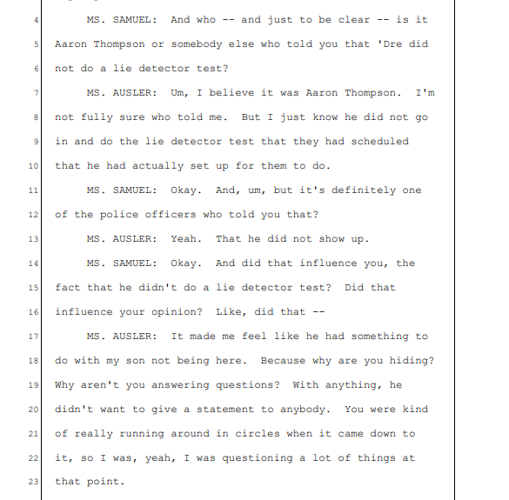
BA 7137. In her interviews with Detective Pavlovich, on December 6, 2017, he repeatedly told her information designed to change her perception:
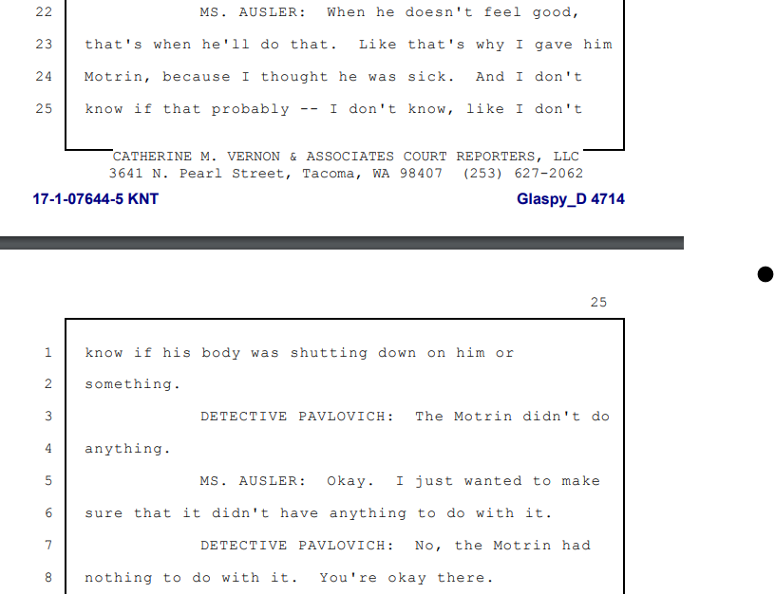
BA 4714-15.
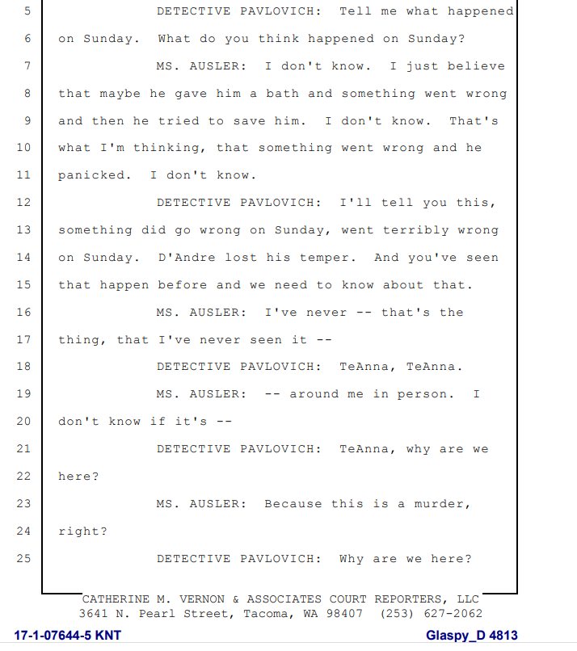
BA 4813.
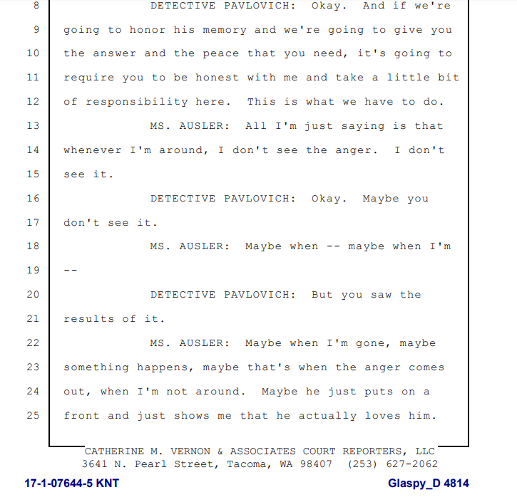
BA 4814.
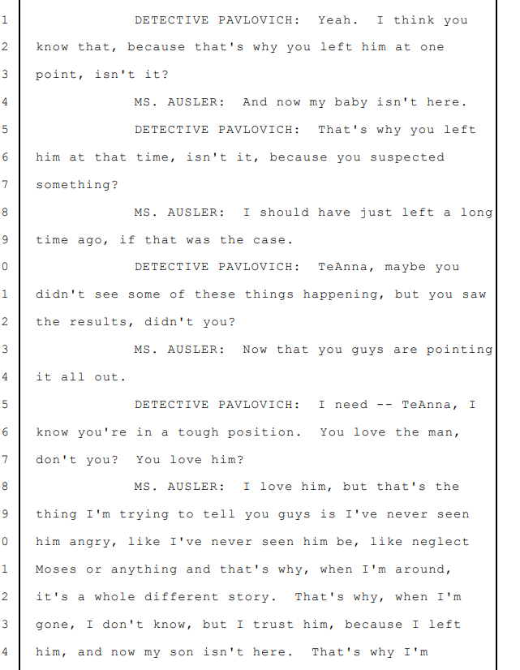
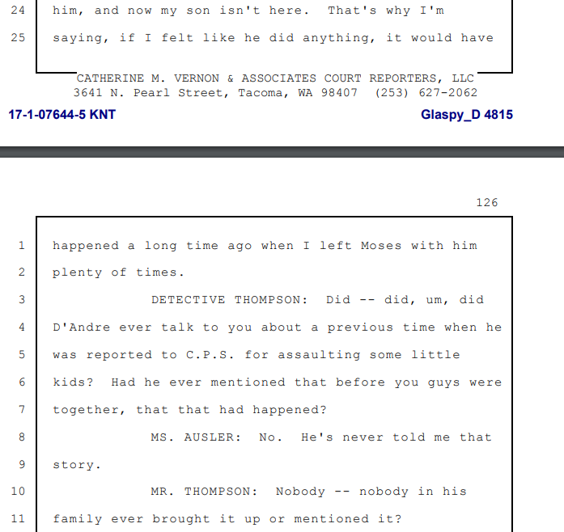
BA 4815-16
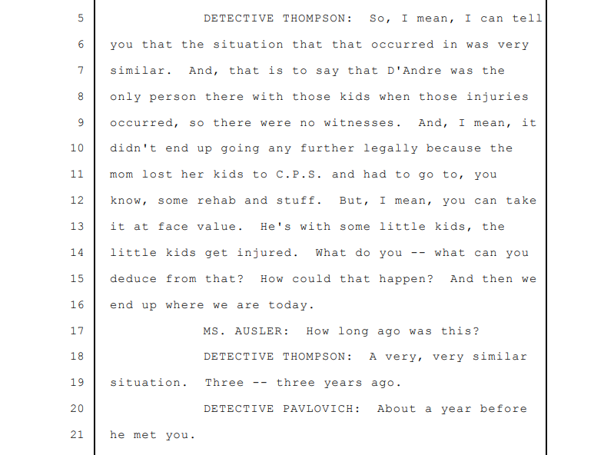
BA 4817. At the end of Ms. Ausler’s interview with detectives, she stated
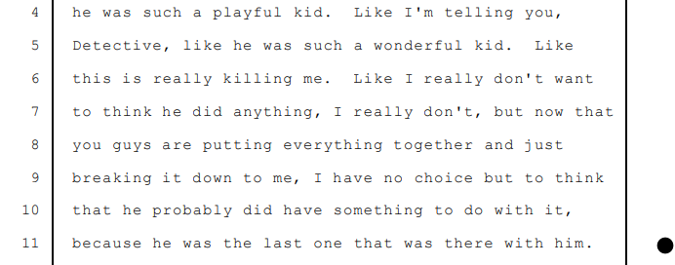
BA 4385. It is clear that the badgering of detectives, coupled with the impact of learning about other cases, and being told by Detective Thompson that Mr. Glaspy did not take a polygraph influenced Ms. Ausler.
Law enforcement also attempted this tactic on Ms. Dyondra Glaspy, telling her during her 12/7/2017 interview 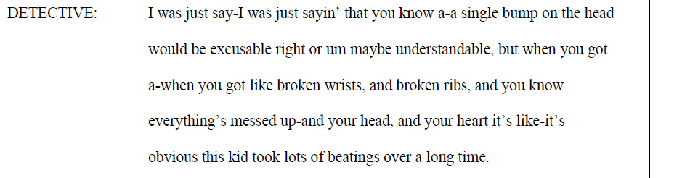
BA 5388.
Looking to State v. Kearney is instructive. In Kearney a prosecutor told several defense witnesses that Mr. Kearney would not submit to a lie detector test. 11 Wn. App. at 394. The Court noted this warranted dismissal. Id. In so ruling it noted that a particularly dispositive factor was a defense psychiatrist who noted in their report “The face that he will not take a lie-detector test makes me Suspect [sic] that something went on between the patient and the girls.” Id. at 395. Two other witnesses, defense character witnesses, were told the same, and asked if they knew “why Mr. Kearny would refuse such a test.” Id.
In ruling that dismissal was appropriate, the Court noted that both the Washington Constitution and the Sixth Amendment guarantee that the accused “shall have the right to compulsory process to compel attendance of witnesses in his own behalf.” Id. It noted, though that:
Granting to a defendant, particularly one accused of having committed a heinous crime, the right to compulsory process, without also granting assurances that the minds of his potential character witnesses will not be unduly influenced by prosecutorial use of inadmissible extraneous material, would rather effectively negate the original right.
Id. at 395-96. It goes on to note that it is “singularly inappropriate for such an official to implant in the mind of a potential witness a suspicion that the accused really did commit the crime. . .”, noting that doing should “would be an attempt to implant a bias of prejudice where presumably none existed.” Id. at 396. The Court found this to be prejudicial misconduct, noting that if such a tactic would put suspicion into the mind of a psychiatrist, then it surely must have been done to lay witnesses. Id. The Court finally noted “there is no way to isolate the prejudice resulting from this prosecutorial activity. The defendant has been effectively deprived of character witnesses in a proceeding in which credibility is a most significant factor.” Id. at 397.
State v. Carol M.D. also proves instructive. In that case , a child indicated that a social worker, therapist, and prosecutor let her know “they thought her parents touched her inappropriately.” 89 Wn. App. At 91. This set of facts “indicate[d] possible misconduct by the State that may have infringed on their right to compulsory process.” Id. at 92.
Here, the facts of what occurred with detectives sharing irrelevant facts, facts that would never be admissible in court – such as a polygraph – to multiple witnesses denies Mr. Glaspy his right to compulsory process. Ms. Ausler’s statements, showcase how grave this misconduct was: but now that you guys are putting everything together and just breaking it down to me, I have no choice but to think that he probably did have something to do with it, because he was the last one that was there with him” BA 4835. After Detective Pavlovich force fed Ms. Ausler his personal beliefs as to what occurred – she indicated that she now “had no choice but to think he probably did have something to do with it.” This statement is virtually identical to the problematic statement that warranted dismissal of four counts of child molestation in Kearney. The tactic of telling Ms. Ausler subjectively what Detective Pavlovich believed happened is nearly identical to the prosecutor in Carol M.D. stating to the alleged victim that he believed she had been touched – a statement that warranted reversal of a Rape of a Child in the First Degree and Child Molestation in the First Degree. This all was exacerbated by Detective Thompson telling Ms. Ausler that Mr. Glaspy refused to take a lie detector, which “made [her] feel like he had something to do with my son not being here. Because why are you hiding?” BA 7137. This was the “singularly inappropriate” conduct proscribed in Kearney. But worse than in Kearney, where the Court was forced the speculate that such a tactic would plant suspicion and bias into the mind of lay witnesses, here we know that such tactic did plant suspicion is a witness critical to evaluating how M.Z.H.-A. and Mr. Glaspy interacted. Because these facts are so egregious, because these tactics have denied Mr. Glaspy the right to compulsory process to have untainted witnesses testify on his behalf, the only possible remedy is dismissal. Kearney, 11 Wn. App. at 397.
V. CONCLUSION
This memorandum has been prepared solely to acquaint the trial court with the issues as they will be presented at trial. The Defense asks this Court to grant the above motions.

DATED this 2nd day of December 2022.

/s/Michael A. Schueler – esigned 12/2/2022
Anna Samuel, WSBA # 23444
Michael A. Schueler, WSBA # 47840
Attorneys for D’Andre Glaspy

Information gathered from Jail booking information
Purpura appears similar to a bruise – they appear as small flat spots on the skin that, in darker colored skin, appear brownish or black, versus more red/purple in lighter colored skin. Purpura, Cleveland Clinic, https://my.clevelandclinic.org/health/symptoms/22695-purpura (accessed 11/19/2022 at 4:00 pm). It frequently occurs from disseminated intervascular coagulation. Purpura, DemNet, https://dermnetnz.org/topics/purpura (accessed 11/19/2022 at 4:00pm). 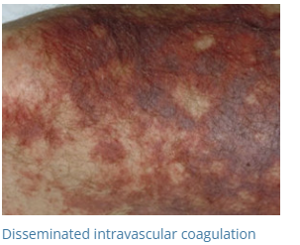Id. An example of a darker skinned person with purpura is as follows: 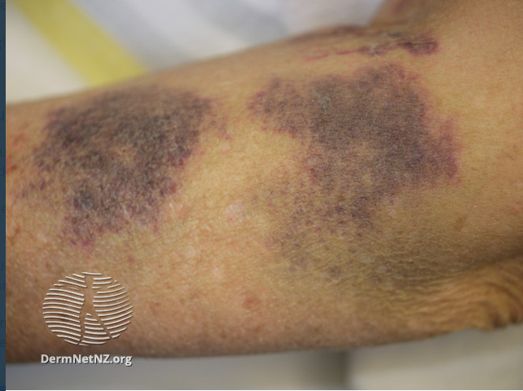 Senile Purpura (although a different cause, the condition is the same). DermNet, https://dermnetnz.org/topics/senile-purpura (accessed 11/19/2022 at 4:04pm).
See E. Fosse, H. Lindberg, Left Ventricular Rupture Following External Chest Compression, https://pubmed.ncbi.nlm.nih.gov/8738698/ (Accessed 12/1/2022, 3:21 pm) Appendix A; Natsuaki, M, et. Al, Right Ventricular Rupture induced by cardiopulmonary resuscitation, https://www.journalofcardiologycases.com/article/S1878-5409(09)00019-X/fulltext (Accessed 12/1/2022, 3:21 pm) (noting at the end that both left and right ventricular rupture should be considered when viewed post CPR). Appendix B.
Dr. Feldman and others began writing a paper postulating on this novel theory within a few days of M.Z.H.-A.’s death – well before the final autopsy report was issued.
His report is Appendix C.
His report is Appendix D.
Her report is Appendix E.
It is important to note that the Defense Expert witnesses came to their conclusions primarily in a vacuum. They did not consult or work with other doctors back and forth. Although Dr. Julie Mack was retained on the suggestion of Dr. Carl Wigren, they did not ultimately connect other than a scant few emails without associated response. Their opinions are squarely their own. This is in stark contrast to the State witnesses who repeatedly met together (though they failed to keep notes) and seemed to let Dr. Feldman suggest possible things he would like to see in order to support his paper.
His reports are Appendix F.
His report is Appendix G
For ease of reference through the statement of facts, Defense will refer to parties by their first names or nicknames that came up throughout the investigation. Mr. D’Andre Glaspy goes by “Drako” or “Dre”; Ms. TeAnna Ausler goes by “TeAnna” or “TT”; Ms. Shannon Schultz goes by “Shannon” and has occasionally used the last name of “Osborne”; Mr. Jonathan Harris goes by “JRock.”; Ms. Dyondra Glaspy goes by “Dyondra” or “DD”. Defense intends no disrespect to any witness by referring to them colloquially throughout portions of the brief.
Battle rap, with stylistic roots in poetry, sound clash culture, and griots (a West African traditional oral historian) is a type of rapping that is performed between two or more people, often freestyled spontaneously, that includes boasts, insults, and clever wordplay. Often, MCs will judge the participants to determine who won the battle. Battle Rap, Wikipedia (https://en.wikipedia.org/wiki/Battle_rap) (accessed 11/27/2022 at 5:44 pm).
Appendix H.
Transcripts of her interview are attached as Appendix I.
Worth noting, Dr. Harruff indicated that the King County Medical Examiner’s Office sees, at most, six child abuse cases a year. Defense Interview, Page 20, line 19-20: This case occurred during Dr. Yarid’s first year as a Medical Examiner with King County. Including her fellowship, she had only 4 years’ experience when this autopsy occurred.
Dr. Feldman, in interview with Defense, noted that no one even considered the possibility that there could have been another possible cause of death. This is troubling given the clear evidence discovered when defense expert doctors reviewed the evidence and conducted additional testing.
In various interviews, both Dr. Yarid and Dr. Feldman admit that several internal injuries found on autopsy of M.Z.H.-A. could have resulted from CPR. Various literature cited in their own paper further confirms that several injuries could occur from CPR.
Appendix J: Valerie P. Hans & Alayna Jehle, Avoid Bald Men and People with Green Socks? Other Ways to Improve the Voir Dire Process in Jury Selection, 78 CHI.-KENT L. REV. 1179, 1195 (“The desire to appear favorably is a main concern of prospective jurors, and that shapes the attitudes and opinions that they disclose during the voir dire. Therefore, prospective jurors are hesitant to share embarrassing experiences and beliefs because of the broad audience that can learn of their responses. The lawyer, the judge, and other prospective jurors would hear their responses, in addition to the rest of the public and the court reporter who records their words into official documentation that can be seen by others in the future.”).
Appendix K: Brian A. Nosek, Carlee Beth Hawkins & Rebecca S. Frazier, Implicit Social Cognition: From Measures to Mechanisms, 15 TRENDS COGNITIVE SCI. 152, 154 (2011).
Appendix L: Kathy Kellermann, Online Jury Research Update Blog, July 2011 (Issue 4) at http://www.kkcomcon.com/CCOnlineJuryResearchUpdateByDate.htm?goback=%2Egde_1642 217_member_64911084 citing Flores, D.M. Methods of expanded voir dire and written questionnaires: Experimental results on juror self-disclosure and implications for trial practice. COURT CALL, pp. 1-6 (Summer 2011).
Appendix M: Jury Diversity and Implicit Bias: Tilting the Scales Toward Racial Balance.
Appendix N: Mark W. Bennett, Unraveling the Gordian Knot of Implicit Bias in Jury Selection: The Problems of Judge-Dominated Voir Dire, the Failed Promise of Batson, and Proposed Solutions, 4 HARV. L. & POL’Y REV. 149, 161 (2010) (“As a district court judge for over fifteen years, I cannot help but notice that jurors are all too likely to give me the answer that they think I want, and they almost uniformly answer that they can “be fair.”).
Black, Indigenous, People of Color
Appendix O.
Appendix P.
Appendix Q.
Appendix R.
Appendix S.
Defense Counsel Schueler was one of the appellate lawyers on Erickson. He has subsequently lectured on the subject of GR 37 at Washington Defender Association conferences, to the Kitsap County Bar Association, to the New Jersey judiciary upon their adoption of attorney conducted voir dire and a GR 37 similar rule, and will present in 2023 at the Washington Judicial Conference with Judge Michael Ryan, Judge Stanley Rumbaugh, and attorneys Lila Silverstein and La Rond Baker.
Appendix T.
Appendix U.
Appendix V.
Appendix W.
At page 95, lines 16-21 of her first defense interview, Dr. Yarid notes that she is certain that it takes exactly five days for macrophages to show up, but notes that “I would think several days is, yes, accurate.”
State v. Franklin, 180 Wn.2d 371, 325 P.3d 159 (2014).
This flawed line of thinking has been called into question under City of Seattle v. Wiggins, -- Wn. App. 2d --, 515 P.3d 1029 (2022) (holding that a different toxicologist testifying for what another toxicologist had done was violative of Mr. Wiggins’ Confrontation Rights under Article I, Section 22 and the Sixth Amendment).
There is no authority, for example, to suggest “that the State has a right to confront witnesses equal to the defendant’s Sixth Amendment Right.” Cayetano-Jaimes, 190 Wn. App. At 302.

